Skillshare360

Requirements Specification

Version 1.0

April 19, 2023

**Table of Contents**

**1.** **EXECUTIVE SUMMARY 3**

1.1 Project overview 3

1.2 Purpose and scope of this specification  3

**2.** **PRODUCT/SERVICE DESCRIPTION 3**

2.1 Product Context 3

2.2 User Characteristics 3

2.3 Assumption 3

2.4 Constraints 3

2.5 Dependencies 4

**3.** **REQUIREMENTS 4**

3.1 Functional Requirements 4

3.2 Non-Functional Requirements 5

*3.2.1* Product Requirements 5

**3.2.1.1** User Interface Requirements 6

**3.2.1.2** Usability 6

**3.2.1.3** Efficiency 6

3.2.1.3.1 Performance Requirements 6

3.2.1.3.2 Space Requirements 6

**3.2.1.4** Dependability 6

**3.2.1.5** Security 7

*3.2.2* Organizational Requirements 7

**3.2.2.1** Environmental Requirements 7

**3.2.2.2** Operational Requirements 7

**3.2.2.3** Development Requirements 7

*3.2.3* External Requirements 7

**3.2.3.1** Regulatory Requirements 7

**3.2.3.2** Ethical Requirements 7

**3.2.3.3** Legislative Requirements 7

3.2.3.3.1 Accounting Requirements 7

3.2.3.3.2 Security Requirements 7

3.3 Domain Requirements 7

**4.** **Software Design** 7

4.1 User Scenarios 7  
4.2 Use Cases 7  
4.3 Use Cases Extended 7  
4.4 BPMN 7  
4.5 Data Flow Diagram 7  
4.6 Entity-Relationship Diagram 7  
4.7 Activity Diagrams 7  
4.8 Timing Diagram 7  
4.9 State Diagram 7  
4.10 Sequence Diagrams 7  
4.11 Collaboration Diagrams 7  
4.12 Class Diagram 7  
4.13 Object Diagram 7  
4.14 Package Diagram 7  
4.15 Component Diagram 7  
4.16 Deployment Diagram 7

**5. Design Patterns 7**

**6. Appendix** **7**

# Executive Summary

## Project Overview

## Our online learning platform is a web-based application created to give learners access to educational materials and content, including video lectures, interactive tests, and readings. Our platform is built to meet the needs of a variety of learners, including lifelong learners, professionals, and students.

## Purpose and Scope of this Specification

The purpose of this project is to develop an online learning platform that provides learners with access to high-quality educational content and resources. The platform will be designed to cater to the needs of different types of learners, including students, professionals, and lifelong learners.

Within the scope:

* Design and development of the user interface, database, and functionality for the online learning platform.
* Producing and collecting educational materials and information, including reading materials, interactive quizzes, and video lectures.
* Features for user registration, authentication, and account administration.
* The use of customized learning environments that take into account the unique requirements and preferences of each student.
* Connectivity with tools and platforms from other companies, such as payment gateways, email marketing applications, and social media sites.
* The platform's quality control and testing to make sure it is dependable, secure, and available to all users.
* The platform's deployment to a reputable hosting environment.

Outside the scope:

* Development of user-specific hardware or software.
* Creating unique material for particular clients or groups.
* Localization of the platform to fit different linguistic or cultural backgrounds.
* Reaching out to potential users to market or promote the platform.
* The platform's ongoing maintenance and support after its first deployment.
* Creating mobile applications that go beyond the platform's basic features.
* Platform customization that goes beyond the predetermined needs and standards.

# Product/service description

Skillshare360 is an online learning platform that offers a wide range of courses and tutorials on various subjects and skills. The platform is designed to provide learners with a personalized and interactive learning experience, allowing them to access high-quality educational content and connect with a community of like-minded learners and instructors.

The website offers courses on diverse topics such as business, technology, design, photography, music, art, and more. These courses are created and taught by experienced instructors, who bring their expertise and insights to the platform. Users can sign up for free and create a profile, which allows them to browse and enroll in courses that suit their learning objectives and preferences, access them from anywhere.

The flexible interface allows learners to navigate through courses, track their progress, and interact with other learners and instructors. The platform provides various features such as quizzes, assignments, study groups, and discussions, that help learners to deepen their understanding and engage with the course content. After completing a course or fishing a quiz or assignment the user will be reworded with a medal or a badge for completing the course.

In addition, Skillshare360 offers Premium and Instructor accounts that provide access to exclusive content, early course access, personalized recommendations, and other advanced features. Premium users can create their own study groups and invite other learners to join, while instructors can create and sell their own courses, connect with potential clients, and participate in virtual events and workshops

## Product Context

The website is an online learning platform whose purpose is to enable the learner to participate in online courses provided by numerous instructors and facilitate the interaction between the learners with instructors and other learners as well. Because the technology is advancing the idea was created to make it more convenient for the learners to take courses from the comfort of their own home, on their own schedule. This makes it easier for people to learn new skills and gain knowledge that can help them in their personal and professional lives.

The platform is designed to be user-friendly, providing learners with a seamless and engaging learning experience that can be accessed anytime, anywhere.

Skillshare360 provides learners with a variety of tools and resources to enhance their learning experience. In addition to course materials, learners can take quizzes and complete assignments to test their knowledge and skills. If they need to revisit a previous lesson, they can easily access it through the platform and rewatch it at their own pace. With a diverse range of courses, expert instructors, and a supportive learning community, Skillshare360 is changing the way people learn and helping them to achieve their goals.

## User Characteristics

Create general customer profiles for each type of user who will be using the product. Profiles should include:

**Learner**

* Access thousands of courses taught by experts
* Learn at your own pace
* Join a community of learners
* Take many quizzes and Assignments
* Access courses on many devices
* Get feedback on your progress
* Get a Certificate of Completion
* Register for upcoming activities
* Log in or sign up with your own email
* Contact developers for any error in the website
* Subscribe to different instructors
* Unsubscribe from the content-creators
* View other user’s profile
* Payment online
* Search about the courses they are interested in

**Premium**

* All Learner functionalities
* Access to exclusive courses
* Create your own community to study with your friends
* Manage your community by inviting new members
* Ban someone from your community
* Check the recommended courses generated based on your selections
* Many discounts
* Early Access to new courses
* Contact the instructor at any time
* Attend webinars with industry experts
* Free access to downloadable resources
* Priority Support
* Notification for any upcoming activates
* Check upcoming activities regardless if you are registered or not
* Cancel their Premium subscription

**Instructor**

* All of the premium functionalities
* Create your own courses
* Publish your own contents
* Upload quizzes for students to take
* Upload assignments for students to take
* Update your previously generated content.
* Communicate with users that request for your help
* Get insights into your course’s Performance
* Access instructor-only resources
* Get notified for any students’ question.

## Assumptions

* It is assumed that the user has a certain level of technical proficiency and reliable access to internet and devices to use the website efficiently
* It is assumed that the user has enough time to dedicate to learn or participate in courses and to engage in the learning community
* The mobile devices are assumed to have either IOS or Android Operating System.
* It is assumed that the instructor will provide helpful content and has the necessary qualification.
* It is assumed that the user will not download the lectures and published them as their own content
* It is assumed that the instructor has all the necessary equipment to provide quality content
* It is assumed that the courses will be in different languages to break the language barrier
* It is assumed that most of the users are familiar with the English language.
* It is assumed that the instructor will read the users question and will properly respond them.

## Constraints

* In order to continuously enhance their courses, instructors rely on the platform to deliver analytics and data on course success, such as enrollment rates, completion rates, and student feedback.
* The user can view course material only after enrolling in the course.
* The instructor can only participate in virtual events and workshops only if they have an active course.
* The user needs to be logged in so he can contact the instructor.
* The user can see another user’s page only if the page is public.

## Dependencies

List dependencies that affect the requirements.

* Without the owner’s consent the user is not permitted to join a community.
* Students rely on instructors to deliver high-quality course material and respond to inquiries and feedback.
* The platform's premium customers utilize it for access to special content and recommendations for tailored courses based on their learning preferences and past academic performance.
* In order to improve the content of their courses, instructors rely on students to enroll in them and submit feedback.
* In order to reach a larger audience and sell more courses, instructors rely on the platform to support their marketing and promotional efforts.
* The platform must offer dependable and secure payment processing for course fees and other transactions if learners and Premium users are to use it.
* The platform is used by instructors to create and deliver online courses. It offers resources and tools like course templates, software for recording and editing videos, and guidelines for instructional design.
* In study groups, participants rely on one another to contribute actively to conversations and offer feedback on tasks and projects.
* In order to continuously enhance their courses, instructors rely on the platform to deliver analytics and data on course success, such as enrollment rates, completion rates, and student feedback.
* The user can view course material only after enrolling in the course.
* The instructor can only participate in virtual events and workshops only if they have an active course.
* The user needs to be logged in so he can contact the instructor.
* The user can see another user’s page only if the page is public.

# 

# Requirements

## Functional Requirements

| **Req#** | **Requirement** | **Comments** | **Priority** | **Date Rvwd** | **SME Reviewed / Approved** |
| --- | --- | --- | --- | --- | --- |
| R_01 | The app will offer different views for different user levels (Learner, Premium, Instructor) | Based on the role and the account type of the user the app will provide different views | 1 | 15.05.2023 | Mateo Gjini  Ilvio Çumani  Joan Gjergo |
| R_02 | The instructor account must have all the privileges of the system | The admin account has full access to all functionalities of the website. | 1 | 15.05.2023 | Mateo Gjini  Ilvio Çumani  Joan Gjergo |
| R_03 | Users should accept terms of conditions to proceed with registration | When the user creates his account, he should review and accept the terms and conditions in order to continue with the registration | 1 | 15.05.2023 | Mateo Gjini  Ilvio Çumani  Joan Gjergo |
| R_04 | System must verify if a new user signs up with an existing email | A user can’t create an account with an email that is already used by another account | 1 | 15.05.2023 | Mateo Gjini  Ilvio Çumani  Joan Gjergo |
| R_05 | A user will log in by email and password | The user should enter his email and password every time he wants to log in with his account | 1 | 15.05.2023 | Mateo Gjini  Ilvio Çumani  Joan Gjergo |
| R_06 | Learners and Premium can apply for every course they want to take | Learners should be able to enter the courses they want to take | 1 | 15.05.2023 | Mateo Gjini  Ilvio Çumani  Joan Gjergo |
| R_07 | Learners and Premium users should pay the course entry fee | Before a user can view the course material, he must pay for the course he is taking | 2 | 15.05.2023 | Mateo Gjini  Ilvio Çumani  Joan Gjergo |
| R_08 | Learners and Premium users can enter communities | The first two levels of users can enter a community to learn alongside others | 3 | 15.05.2023 | Mateo Gjini  Ilvio Çumani  Joan Gjergo |
| R_09 | Premium users can create their own community | A premium user has the ability to create his community and invite his friends | 3 | 15.05.2023 | Mateo Gjini  Ilvio Çumani  Joan Gjergo |
| R_10 | A Premium user can manage their community | The user that created his community can also manage it by banning other users | 3 | 15.05.2023 | Mateo Gjini  Ilvio Çumani  Joan Gjergo |
| R_11 | A community can be public or private | A public community let’s all users be part of it but to join a private community you need permission | 3 | 15.05.2023 | Mateo Gjini  Ilvio Çumani  Joan Gjergo |
| R_12 | An instructor can create his courses | An instructor that wants to create a new course can do so by filling the required form | 1 | 15.05.2023 | Mateo Gjini  Ilvio Çumani  Joan Gjergo |
| R_13 | An instructor can upload materials related to the course | The instructor can post notes, lectures or videos containing the content of the course | 2 | 15.05.2023 | Mateo Gjini  Ilvio Çumani  Joan Gjergo |
| R_14 | When a new user creates an account as an instructor, he is obligated to upload a cv or resume attached to his account | The resume will function as a way for the users to determine if the course is good | 2 | 15.05.2023 | Mateo Gjini  Ilvio Çumani  Joan Gjergo |
| R_15 | The instructor must be notified when he gets a message | If a Premium user has a question the instructor should be notified | 1 | 15.05.2023 | Mateo Gjini  Ilvio Çumani  Joan Gjergo |
| R_16 | An instructor should respond within seven days | The website will keep track of the time span | 2 | 15.05.2023 | Mateo Gjini  Ilvio Çumani  Joan Gjergo |
| R_17 | An instructor can provide quizzes | This will help members test their skills and what they learned | 3 | 15.05.2023 | Mateo Gjini  Ilvio Çumani  Joan Gjergo |
| R_18 | An instructor can provide assignments | This help students practice their new skills | 2 | 15.05.2023 | Mateo Gjini  Ilvio Çumani  Joan Gjergo |
| R_19 | The system should ensure data security | The system should use secure encryption and authorization mechanism | 1 | 15.05.2023 | Mateo Gjini  Ilvio Çumani  Joan Gjergo |
| R_20 | The system should generate reports and analytics | The system should be able to analyze data trends, patterns and user behaviors | 1 | 15.05.2023 | Mateo Gjini  Ilvio Çumani  Joan Gjergo |
| R_21 | The website should provide a search bar to find courses and communities | Ease of access to search for specific courses or communities | 1 | 15.05.2023 | Mateo Gjini  Ilvio Çumani  Joan Gjergo |
| R_22 | The website should have a recommendation system for courses and communities available only for Premium users | Based on user activity, the system should recommend relevant courses and communities | 2 | 15.05.2023 | Mateo Gjini  Ilvio Çumani  Joan Gjergo |
| R_23 | The website should allow Learners to rate and review courses | Learners should be able to rate and review courses they have taken | 2 | 15.05.2023 | Mateo Gjini  Ilvio Çumani  Joan Gjergo |
| R_24 | The website should notify the user if a course that he is taking posted a new material | Notifies the users about the latest updates in the course | 2 | 15.05.2023 | Mateo Gjini  Ilvio Çumani  Joan Gjergo |
| R_25 | The website should provide a feature to bookmark courses and communities | Users should be able to bookmark courses and communities they are interested in | 3 | 15.05.2023 | Mateo Gjini  Ilvio Çumani  Joan Gjergo |
| R_26 | The website should provide a progress tracking system for courses | Users should be able to track their progress in a course and see how much they have completed | 1 | 15.05.2023 | Mateo Gjini  Ilvio Çumani  Joan Gjergo |
| R_27 | The website should allow Premium users to download course materials | Premium users should be able to download the content and watch it offline if they need to | 1 | 15.05.2023 | Mateo Gjini  Ilvio Çumani  Joan Gjergo |
| R_28 | The website should provide a small discount for Premium users | Premium users may gain a small discount. | 3 | 15.05.2023 | Mateo Gjini  Ilvio Çumani  Joan Gjergo |
| R_29 | The website should provide a feature to cancel and refund course fees | Learners should be able to cancel their enrollment and get a refund for course fees | 1 | 15.05.2023 | Mateo Gjini  Ilvio Çumani  Joan Gjergo |
| R_30 | The website should provide a support system for users | Learners and instructors should be able to contact support for any issues they encounter | 1 | 15.05.2023 | Mateo Gjini  Ilvio Çumani  Joan Gjergo |
| R_31 | The website should have a feature for users to report inappropriate or poor content | Users should be able to report any inappropriate or poor content they come across and be refunded the full price they paid for the course | 3 | 15.05.2023 | Mateo Gjini  Ilvio Çumani  Joan Gjergo |
| R_32 | The website should allow instructors to create a syllabus for their course | Instructors should be able to create a syllabus for their course to provide an overview of the course material to help learners decide if the code is good for them | 1 | 15.05.2023 | Mateo Gjini  Ilvio Çumani  Joan Gjergo |
| R_33 | The Website should have a feature where it displays courses based by their type | The feature will make it easier for users who are looking for a specific type of course | 2 | 15.05.2023 | Mateo Gjini  Ilvio Çumani  Joan Gjergo |
| R_34 | Users can receive points when taking quizzes | When a user takes quizzes, he can receive points based on how well they performed in the quizzes | 2 | 15.05.2023 | Mateo Gjini  Ilvio Çumani  Joan Gjergo |
| R_35 | The user can receive a certificate after completing a course with a high number of points | If a user received a high amount of points from quizzes he with receive a certificate. | 1 | 15.05.2023 | Mateo Gjini  Ilvio Çumani  Joan Gjergo |
| R_36 | Premium users can contact Instructor | If a premium user has a question or something he doesn’t understand he can | 1 | 15.05.2023 | Mateo Gjini  Ilvio Çumani  Joan Gjergo |
| R_37 | A user should be able to subscribe to instructors | If a user likes the content of a instructor he can subscribe to him | 1 | 15.05.2023 | Mateo Gjini  Ilvio Çumani  Joan Gjergo |
| R_38 | A Premium user will receive notification when a new material is posted | When a new material or quiz is published in a course the Premium user will receive a notification | 3 | 15.05.2023 | Mateo Gjini  Ilvio Çumani  Joan Gjergo |

## Non-Functional Requirements

| **Req#** | **Requirement** | **Comments** | **Priority** | **Date Rvwd** | **SME Reviewed / Approved** |
| --- | --- | --- | --- | --- | --- |
| R_01 | Integration | The website should be able to integrate with other tools such as student information systems, video conferencing, plagiarism detectors, etc. | 1 | 28.05.2023 | Mateo Gjini  Edrin Molla  Erli Kuka  Xhensil Gjini |
| R_02 | Usability | The website should be user-friendly and the options should be organized and intuitive. The website should be easy to use by every user. | 1 | 28.05.2023 | Mateo Gjini  Edrin Molla  Erli Kuka  Xhensil Gjini |
| R_03 | Reliability | The website should have an almost uninterrupted uptime. It should have little to none errors and it should be able to handle large amount of traffic. | 1 | 28.05.2023 | Mateo Gjini  Edrin Molla  Erli Kuka  Xhensil Gjini |
| R_04 | Security | The website should be able to protect user data and encrypt sensitive information so unauthorized users cannot access it. | 1 | 28.05.2023 | Mateo Gjini  Edrin Molla  Erli Kuka  Xhensil Gjini |
| R_05 | Performance | The website should be fast and responsive. It should handle data and not slow down for any reasons. | 1 | 28.05.2023 | Mateo Gjini  Edrin Molla  Erli Kuka  Xhensil Gjini |
| R_06 | Compatibility | The website should be compatible with a wide range of screen sizes, browsers and operating systems. | 1 | 28.05.2023 | Mateo Gjini  Edrin Molla  Erli Kuka  Xhensil Gjini |
| R_07 | Scalability | The website should be modular and be very easy to expand in the future with new features. | 1 | 28.05.2023 | Mateo Gjini  Edrin Molla  Erli Kuka  Xhensil Gjini |
| R_08 | Accessibility | The site should be accessible to the impaired users with accessibility standards. | 1 | 28.05.2023 | Mateo Gjini  Edrin Molla  Erli Kuka  Xhensil Gjini |
| R_09 | Privacy | The website should respect user privacy and be compliant with data protection laws. It should seek user consent regarding data collection and use and be transparent about all the actions with them. | 1 | 28.05.2023 | Mateo Gjini  Edrin Molla  Erli Kuka  Xhensil Gjini |
| R_10 | Support | The website should have a helpful and very fast responding support team to help the user with any problem they encounter. | 2 | 28.05.2023 | Mateo Gjini  Edrin Molla  Erli Kuka  Xhensil Gjini |
| R_11 | Searchability | The website should have a robust search function that is returns relevant results quickly and accurately. | 2 | 28.05.2023 | Mateo Gjini  Edrin Molla  Erli Kuka  Xhensil Gjini |
| R_12 | Performance metrics | The website should have performance metrics that allows admins to monitor the performance and engagement of the website. This could include metrics such as page views, user activity, and user feedback. | 3 | 28.05.2023 | Mateo Gjini  Edrin Molla  Erli Kuka  Xhensil Gjini |
| R_13 | Compliance | The website should comply with all the relevant laws and regulations to the specific countries. It should also adhere to industry best practices and guidelines for online learning platforms. | 1 | 28.05.2023 | Mateo Gjini  Edrin Molla  Erli Kuka  Xhensil Gjini |
| R_14 | User tracking | The website should have a system to track user progress and activity on the courses selected. This helps the instructors monitor student progress. | 3 | 28.05.2023 | Mateo Gjini  Edrin Molla  Erli Kuka  Xhensil Gjini |
| R_15 | Internationalization | The website should be able to support international users, currencies, time zones and cultural norms. | 2 | 28.05.2023 | Mateo Gjini  Edrin Molla  Erli Kuka  Xhensil Gjini |
| R_16 | User roles and permissions | The website should have a system for managing roles and permissions to users so to avoid certain users from gaining permissions that they do not have. | 1 | 28.05.2023 | Mateo Gjini  Edrin Molla  Erli Kuka  Xhensil Gjini |
| R_17 | User authentication and authorization | The website should have a secure authentication system that can include 2-factor authentication. | 1 | 28.05.2023 | Mateo Gjini  Edrin Molla  Erli Kuka  Xhensil Gjini |
| R_18 | Mobile learning support | The website should be optimized for mobile devices. This will allow content consumption on the go. | 3 | 28.05.2023 | Mateo Gjini  Edrin Molla  Erli Kuka  Xhensil Gjini |
| R_19 | Gamification | The website should include gamification features. These can be points, badges, and leaderboards. | 3 | 28.05.2023 | Mateo Gjini  Edrin Molla  Erli Kuka  Xhensil Gjini |
| R_20 | Payment processing | The website should have a secure processing system for users to pay for the premium services. | 1 | 28.05.2023 | Mateo Gjini  Edrin Molla  Erli Kuka  Xhensil Gjini |
| R_21 | Data Backups | The website should have regular data backups to ensure data redundancy. | 1 | 28.05.2023 | Mateo Gjini  Edrin Molla  Erli Kuka  Xhensil Gjini |

### Product Requirements

#### **User Interface Requirements**

1. Logged-In Interface:

- The logged-in interface serves as the default interface for all users after they log into Skillshare360. It provides access to various features and functionalities, including:

- Dashboard: A personalized dashboard displaying course recommendations, updates from enrolled courses, and notifications.

- Profile: A section where users can manage their profile information, including profile picture, bio, and privacy settings.

- Search: A search bar and filters to discover courses based on topic, skill level, instructor, and other criteria.

- Enrolled Courses: A list of courses the user has enrolled in, with options to access course materials and track progress.

- Study Groups: A section where learners can join or create study groups to collaborate and discuss course topics.

- Messages: A messaging system for users to communicate with instructors, other learners, and administrators.

2. Learner Interface:

- The learner interface is designed specifically for learners who have a basic Skillshare360 account. In addition to the features available in the logged-in interface, it includes:

- Course Catalog: A comprehensive catalog showcasing available courses, with detailed descriptions, ratings, and reviews.

- Progress Tracking: A visual representation of the learner's progress within enrolled courses, including completed lessons and quizzes.

- Discussion Forums: Dedicated forums where learners can engage in course-related discussions, ask questions, and seek assistance from instructors and peers.

- Certificates: A section displaying earned certificates upon completing courses, with options to download or share them.

3. Premium Interface:

- The premium interface is accessible to users who have upgraded to a premium Skillshare360 account. It includes all the features available in the learner interface, along with additional premium-exclusive features such as:

- Personalized Recommendations: A curated list of course recommendations based on the learner's interests, preferences, and previous course history.

- Messages: A messaging system for premium users to communicate with instructors.

4. Instructor Interface:

- The instructor interface is designed specifically for instructors who create and sell courses on Skillshare360. It includes all the features available in the premium interface, along with additional instructor-specific tools and functionalities, such as:

- Course Creation: A comprehensive course creation toolset, allowing instructors to upload videos, create quizzes, and organize course materials.

- Sales Dashboard: A dashboard providing detailed insights into course sales, revenue earned, and student engagement metrics.

- Communication Tools: Tools to communicate with enrolled users, send announcements.

- Instructor Profile: An enhanced profile section that showcases the instructor's expertise, bio, and a portfolio of courses they offer.

#### **Usability**

Learnability:

* User Documentation: Skillshare360 will provide comprehensive user documentation that covers all the features and functionalities of the platform. The documentation will be easily accessible and available in a user-friendly format, such as online help or downloadable guides.
* Context-Sensitive Help: The help system will be context-sensitive, meaning it provides relevant guidance and instructions based on the user's current task or location within the platform. This ensures that users can easily find the information they need to accomplish common tasks without searching extensively.
* Ease of Learning: Skillshare360 will have an intuitive and user-friendly interface that is easy to navigate and understand. The platform will employ consistent design patterns, clear labeling, and logical workflows to minimize the learning curve for new users.

#### **Efficiency**

* Streamlined Workflows: The system will be designed to optimize common user workflows and tasks, reducing the number of steps required to accomplish them. This includes features such as one-click enrollment, quick access to course materials, and easy-to-use navigation menus.
* Shortcut Keys: Skillshare360 may include shortcut keys or keyboard shortcuts to allow users to perform common actions more efficiently. These shortcuts will be documented and easily discoverable by users.

##### Performance Requirements

* The website will have fast page load times and responsive user interfaces to ensure a smooth user experience.
* Course videos will stream seamlessly without buffering issues, providing a high-quality viewing experience.
* The platform will be capable of handling a large number of concurrent users without significant performance degradation.

##### Responsiveness

* User Interface Responsiveness: The user interface of Skillshare360 will be highly responsive, providing smooth and interactive user experiences across different devices and screen sizes, including desktop computers, laptops, tablets, and smartphones. The interface will adapt and optimize the layout and content presentation based on the user's device, ensuring readability, accessibility, and ease of use.
* Page Load Time: Skillshare360 will aim for fast page load times to minimize user wait times and provide a seamless browsing experience. The platform will optimize the loading of web pages, course materials, images, and other content to ensure quick access and responsiveness, even under varying network conditions.

#### **Dependability**

1. **Availability:**

* Hours of Operation: Skillshare360 will be available for users 24 hours a day, 7 days a week, allowing access to courses and platform functionalities at any time.
* Level of Availability Required: The platform will strive for a high level of availability, aiming for a minimum uptime percentage to ensure users can access the system reliably.
* Coverage for Geographic Areas: Skillshare360 will be accessible to users globally, without geographic restrictions, ensuring availability to learners and instructors from different regions.
* Impact of Downtime: Downtime will be minimized to avoid disruption to users and business operations. The impact of downtime, such as loss of revenue, user dissatisfaction, and negative reputation, will be kept minimal.
* Impact of Maintenance: Scheduled maintenance will be communicated to users in advance, and efforts will be made to schedule maintenance during low usage periods to minimize the impact on uptime. Unscheduled maintenance will be kept to a minimum, with prompt resolution of any issues affecting availability.

1. **Monitoring:**

Skillshare360 will have a robust monitoring system in place to track the health and performance of the platform. This includes monitoring for failure conditions, error detection, system logs, and corrective actions to ensure the system functions reliably.

1. **Maintenance:**

The system will be designed with ease of maintenance in mind, ensuring modularity, clear interfaces, and manageable complexity. These attributes facilitate efficient maintenance activities, such as updates, bug fixes, and enhancements, without disrupting the overall functionality of the platform.

1. **Integrity:**

Data Integrity: Skillshare360 will ensure the integrity of user data, including user profiles, course progress, and communication records. Measures such as data backups, security controls, and error-checking mechanisms will be implemented to maintain data integrity and prevent unauthorized modifications or loss.

#### **Security**

**1. Encryption:**

- Skillshare360 will implement encryption mechanisms to protect sensitive data in transit and at rest.

- Encryption will be applied to communication channels to secure data transmission between users and the platform.

- Sensitive data stored in databases or file systems will be encrypted using strong encryption algorithms and properly managed encryption keys.

**2. Activity Logging and Historical Data Sets:**

- Skillshare360 will maintain detailed activity logs that capture user actions, system events, and other relevant activities.

- The logs will be stored securely and regularly monitored to detect and investigate any suspicious or unauthorized activities.

- Historical data sets can be used for forensic analysis, auditing, and identifying patterns of misuse or security breaches.

**3. Restrictions on Intermodular Communications:**

- Skillshare360 will enforce restrictions on intermodular communications within the system.

- Access controls and permissions will be implemented to ensure that only authorized modules or components can communicate with each other.

- Unauthorized or insecure communications between modules will be prevented to mitigate the risk of unauthorized access or data breaches.

**4. Data Integrity Checks:**

- Skillshare360 will employ data integrity checks to ensure that data remains intact and unaltered.

- Hashing algorithms or digital signatures can be used to verify the integrity of data, preventing unauthorized modifications or tampering.

- Regular integrity checks will be performed on critical data to detect any inconsistencies or unauthorized changes.

**3.2.2 Organizational Requirements**

**3.2.2.1 Environmental Requirements**

Every user must be held responsible for the information provided by him for the platform in case of mismatch between the user information and the information that corresponds to him in the account. Also in case of direct communication between a premium account user and instructor, the question from the user must be course related and provide short and clear information about the concept that the user does not understand, otherwise the instructor can ignore the question without giving a reason. On the other hand the platform system must take into account all other legal and ethical issues relating to the confidentiality of the personal information.

**3.2.2.2 Operational Requirements**

Specification of any operation that the user or instructor requires :

* Approval of a major transaction, such as sign-up or course completion certificate.
* Data integrity is not possible without the administrator's approval.
* Limitation of usability when the premium access is not approved by the system.
* The application will be available to the user 24/7.
* Course materials from instructors can be accessed only by approved joined users/premium.
* Create, Read, Update and Delete users.
* Create, Read, Update and Delete courses.
* Create, Read, Update and Delete course materials.
* Create a course certificate.
* Create a course related question for the instructor of the course(Premium only).

These operations will be handled by the cloud storage provider.

**3.2.2.3 Development Requirements**

The app will use either Wi-Fi, or mobile data to connect to the internet but the app can show previously downloaded materials from courses even without a connection to the server.

Other network related issues are automatically handled by Firebase Infrastructure,

including connection monitoring, operation queueing during offline periods, etc.

### 

### External Requirements

#### **Regulatory Requirements**

To ensure full compliance with guidelines, standards, and legal requirements, we maintain comprehensive regulation records for our website. These rules are designed to safeguard the safety and security of our website environment. The regulations can be categorized as Draft, Active, or Interactive, depending on their current status. When developing our privacy policies, we adhere strictly to the provisions outlined in Law No.9887, which was enacted on 10.03.2008, and any relevant sub-legal acts. Our privacy policies serve as an informational resource that elucidates the types of information we collect and how we utilize it. One important aspect to note is that IP addresses collected during user sessions are never associated with any personally identifiable information. This means that while we log users' sessions for various purposes, their identities remain anonymous throughout the process. By implementing this approach, we prioritize user privacy and anonymity, creating a safer online experience for our visitors.

#### **Ethical Requirements**

User’s personal identifiable information, such ass an email address, name, surname, phone number, and other information, will never be sold or exchanged to other institutions, enterprises or non-profit organizations.

#### **Legislative Requirements**

Data Protection and Privacy Laws: The website must comply with relevant data protection and privacy laws, such as the General Data Protection Regulation (GDPR) in the European Union or the California Consumer Privacy Act (CCPA) in California. This includes obtaining user consent for data collection and processing, providing privacy policies, and ensuring the security of user data.

Intellectual Property Laws: The website must respect intellectual property rights, including copyrights, trademarks, and patents. It should not infringe on the rights of others by using their copyrighted content without permission or without proper attribution.

Accessibility Laws: The website should be accessible to people with disabilities, in accordance with accessibility laws such as the Web Content Accessibility Guidelines (WCAG). This includes providing alternative text for images, ensuring keyboard navigation, and accommodating screen readers.

Consumer Protection Laws: The website must comply with consumer protection laws, which may include providing accurate product information, clear pricing, fair terms and conditions, and options for returns and refunds.

Anti-Spam Laws: The website should adhere to anti-spam laws, such as the CAN-SPAM Act in the United States, by obtaining consent before sending marketing emails, providing unsubscribe options, and including accurate sender information.

##### Security Requirements

“On the Protection of Personal Data”, the personal information of each user should be private and possible to be accessed only by the specified actors. As a result, the information of learners, premium users, Instructors, and other users is already protected via emails with hashed passwords. This web application will also enforce the latest update on the General Data

Protection Regulation (GDPR) as it became enforceable on June 14, 2022 in EU (European Union) and EEA (European Economic Ares) countries.

## Domain Requirements

**Course Management:**

* The platform should support the creation, organization, and management of courses, including course structure, content, and assessments.
* It should allow instructors to create and upload course materials, such as lectures, assignments, and supplementary resources.
* Course enrollment and registration processes should be implemented to facilitate learner access.

**User Management:**

* The platform should provide user registration and authentication capabilities, allowing learners, instructors, and administrators to create and manage their accounts.
* User profiles should be available for learners to track their progress, manage preferences, and view their course history.
* Role-based access control should be implemented to ensure appropriate access and permissions for different user types.

**Content Delivery:**

* The platform should offer a user-friendly interface for learners to access and interact with course content, including videos, documents, quizzes, and interactive learning materials.
* It should support multimedia formats, providing smooth video streaming, document rendering, and interactive elements for engaging learning experiences.
* Content delivery should be optimized for various devices and screen sizes, ensuring a responsive and accessible user experience.

**Learning Management:**

* The platform should provide features for learners to track their progress, view grades, and receive feedback on assessments and assignments.
* Personalized learning paths should be supported, allowing learners to customize their course selections based on their goals and interests.
* Progress tracking mechanisms, such as completion status and achievement badges, can be implemented to motivate and reward learners.

**Collaboration and Communication:**

* The platform should facilitate communication and collaboration among learners, instructors, and peers through discussion forums, chat features, or virtual classrooms.
* Group work and project management functionalities can be included to enable collaborative assignments and projects.
* Notifications and messaging systems should be in place to keep users informed about course updates, deadlines, and important announcements.

**Assessment and Evaluation:**

* The platform should support various assessment methods, such as quizzes, exams, assignments, and peer evaluations.
* Automated grading and feedback mechanisms can be integrated to provide timely feedback to learners.
* Instructors should have the ability to create and manage assessments and generate reports on learner performance.

**Security and Privacy:**

* The platform should prioritize security measures to protect user data, including secure authentication, data encryption, and regular data backups.
* Privacy controls should be implemented to comply with data protection regulations and allow users to manage their privacy settings.
* Adherence to industry standards and best practices for data security and privacy is crucial.

# Software Design

* 1. ***User Scenarios***

**S_U1: User is not registered.**

1. The user can see the Main page of the website
2. The user can contact us
3. The user can access information about what we do
4. The user can Sign up or Login

**S_U2: User signs up for the first time**

1. User chooses to sign Up by selecting what type of account they want to create
2. User is redirected to the Sign-up page
3. User provides the required information based on the level they selected
4. User pays accordingly
5. User agrees on terms and conditions
6. User clicks Ok
7. Registr4ation is successful and complete

**S_U3: User registers in a new course**

1. User clicks in a course
2. User is presented with information including the course (Instructors CV or a syllabus for the course)
3. The User agrees to pay the fee for the course
4. User is part of the course
5. User can access the course material

**S_U4: User enters a course**

1. User enters the course page
2. User is presented with the course page
3. User can see the next video of the course
4. User selects the video or the material he wants to access
5. User leaves a review on the course
6. User rates the course

**S_U5: User takes a quiz**

1. User enters the course page
2. User is presented with the course page
3. User navigates and selects the quiz he will be taking
4. User finishes the quiz
5. User clicks on a specific button
6. User sees the answers
7. If results are unsatisfactory user does the quiz again

**S_U6: User does an assignment**

1. User enters the course page
2. User is presented with the course page
3. User navigates and selects the assignment
4. User reads the instructions regarding this assignment
5. User finishes the assignment

**S_U7: User finishes the course**

1. User enters the course page
2. User sees the last material for the course
3. User gets the average score from the quizzes he has taken
4. If score is enough and the course provides a certificate
5. User gets a certificate
6. If the user’s score isn’t enough the user can retake quizzes

**S_U8: A registered user Logs In**

1. User enters the main page of the website
2. User clicks the Login button at the top of the page
3. User enters the email
4. User enters the password
5. User submits the form
6. If the email doesn’t exist or the password is incorrect
7. System informs the user
8. If the email and the password is correct
9. User enters his profile page

**S_U9: User Logs In successfully**

1. User logs in
2. User enters his Profile page which changes according to his type
3. If user is a simple learner display only registered courses and finished courses
4. If user is a Premium display the same page as the user and a list with recommended courses
5. If the User is an instructor the profile page displays the same as premium and also add A list of the courses he has created
6. User continues to use the website

**S_U10: User registers to a community**

1. User enters a course
2. User navigates to community page for communities at that course
3. User can filter the communities
4. User selects a community
5. User reads information about the community
6. If the community is public user enters the community
7. If the community is private user waits for the admin to accept him

**S_U11: Learner Upgrades to premium or Instructor**

1. Learner enters his profile page
2. Learner presses the button to Upgrade
3. Learner is presented with the benefits of each level
4. Learner selects to which level he wants to upgrade
5. Learner pays the fee accordingly
6. Learner has upgraded and is returned to his profile page

**S_U12: User Reports inappropriate or poor content**

1. User enters a course
2. User watches the material
3. User find inappropriate or poor material
4. User choses to report the material
5. User fills a form where he provides the reason for the report
6. We get a notification to judge the material

**S_U13: Premium Creates a community**

1. Premium user is logged in
2. Premium user enters his profile page
3. Premium user navigates to his community board
4. Premium user clicks a specific button
5. Premium user is presented with the community creation page
6. Premium user enters a name for his community
7. Premium user sets community to private/public/abstract/protected (Nobody will read this joke)
8. Premium user adds tags to his community
9. Premium user invites friends to instantly join his community

**S_U14: Premium user manages his community**

1. Premium user is logged in
2. Premium user enters his profile page
3. Premium user navigates to his community board
4. Premium user enters one of his communities
5. Premium user clicks on a specific button
6. Premium user changes the name, the privacy or adds/removes tags from the community
7. Premium user saves the changes

**S_U15: Premium user accepts request to join community**

1. Premium user is logged in
2. Premium user enters his profile page
3. Premium user sees a notification at one of his communities
4. Premium user opens the notification
5. Premium user accepts or denies the request
6. If Premium user accepts user enters the community
7. If Premium user denies the user doesn’t enter the community
8. If the premium user ignores the user doesn’t enter the community but the notification stays

**S_U16: Premium user removes a user from his community**

1. Premium user is logged in
2. Premium user enters his profile page
3. Premium user navigates to his community board
4. Premium user enters one of his communities
5. Premium user clicks on a specific button
6. Premium user sees all members of the community
7. Premium user clicks one of the users
8. Premium user clicks another specific button to remove user
9. The user gets removed

**S_U17: Premium user removes a user from his community (Second way)**

1. Premium user is logged in
2. Premium user enters his profile page
3. Premium user navigates to his community board
4. Premium user enters one of his communities
5. Premium user reads an inappropriate message in his community
6. Premium user clicks on the user icon next to the comment
7. Premium user removes the user

**S_U18: Premium messages an instructor**

1. Premium user is logged in
2. Premium user enters his profile page
3. Premium user enters a course
4. Premium user watches material
5. Premium user doesn’t understand something
6. Premium user clicks on the instructor of the course
7. Premium user clicks a specific button to message the instructor
8. Premium user writes his question
9. Premium user enters submit

**S_U19: Instructor creates a new course**

1. Instructor logs in
2. Instructor enters his profile page
3. Instructor navigates to his courses section
4. Instructor clicks in a specific button
5. Instructor is presented with create course page
6. Instructor provides a name for his course
7. Instructor enters tags for his course
8. Instructor may provide a certificate if he wants or if it is necessary
9. Instructor provides a description for the course
10. Instructor provides a sample video for his course
11. Instructor sets a entry fee
12. Instructor clicks submit
13. The course is added to instructors My Courses section

**S_U20: Instructor responds to a Premium user**

1. Instructor is logged in
2. Instructor enters his profile page
3. Instructor navigates to his courses section
4. Instructor sees a notification to one of his courses
5. Instructor opens the message
6. Instructor provides an answer
7. Instructor clicks submit

**S_U21: Instructor adds material to the course**

1. Instructor is logged in
2. Instructor enters his profile page
3. Instructor selects one of his courses
4. Instructor adds new material in the format of a video or a file
5. Instructor clicks submit

**S_U22: Instructor adds a quiz**

1. Instructor is logged in
2. Instructor enters his profile page
3. Instructor selects one of his courses
4. Instructor clicks a specific button
5. Instructor is presented with the quiz creation page
6. Instructor adds a question
7. Instructor adds some alternatives
8. Instructor selects which is correct
9. The instructor presses a specific button for each question he wants to add
10. Instructor clicks submit

**S_U23: Instructor adds an assignment**

1. Instructor is logged in
2. Instructor goes to his profile page
3. Instructor selects one of his courses
4. Instructor clicks a specific button
5. Instructor is presented with the assignment creation page
6. Instructor adds a topic for the assignment
7. Instructor adds a description
8. Instructor adds a requirement
9. Instructor submits the assignment

**S_U24: Instructor adds certificate to a course**

1. Instructor is logged in
2. Instructor goes to his profile page
3. Instructor open’s one of his courses
4. Instructor adds a certificate to the course
5. If the course doesn’t have a certificate add the certificate
6. If the course already has a certificate inform the instructor about the change that is going to happen
7. If instructor wants to change the certificate replace the previous certificate with the new one
8. If instructor doesn’t want to change discard the new certificate
9. Instructor clicks submit

**S_U25: Instructor delete’s a course**

1. Instructor is logged in
2. Instructor goes to his profile page
3. Instructor selects one of his courses
4. Instructor clicks the delete button
5. Instructor gets a prompt if he really wants to delete the course
6. If yes, the course is deleted
7. If not the course stays and the instructor is sent back to his profile page

***4.2 Use cases***

Use Case 1 Learner

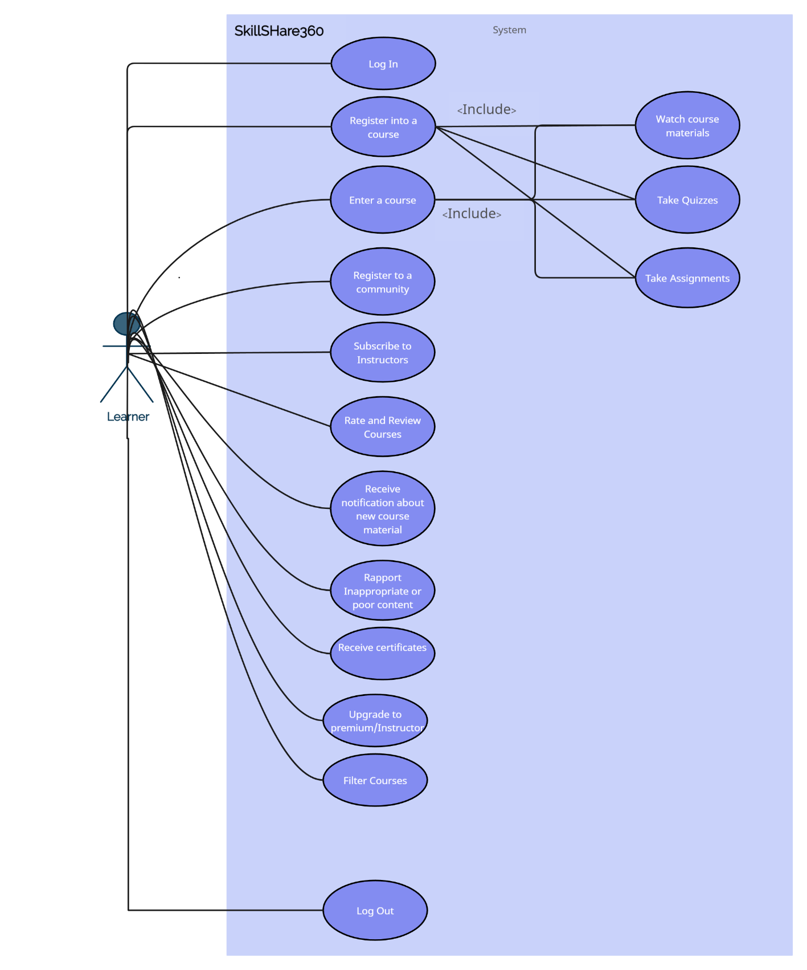

Use Case 2 Premium

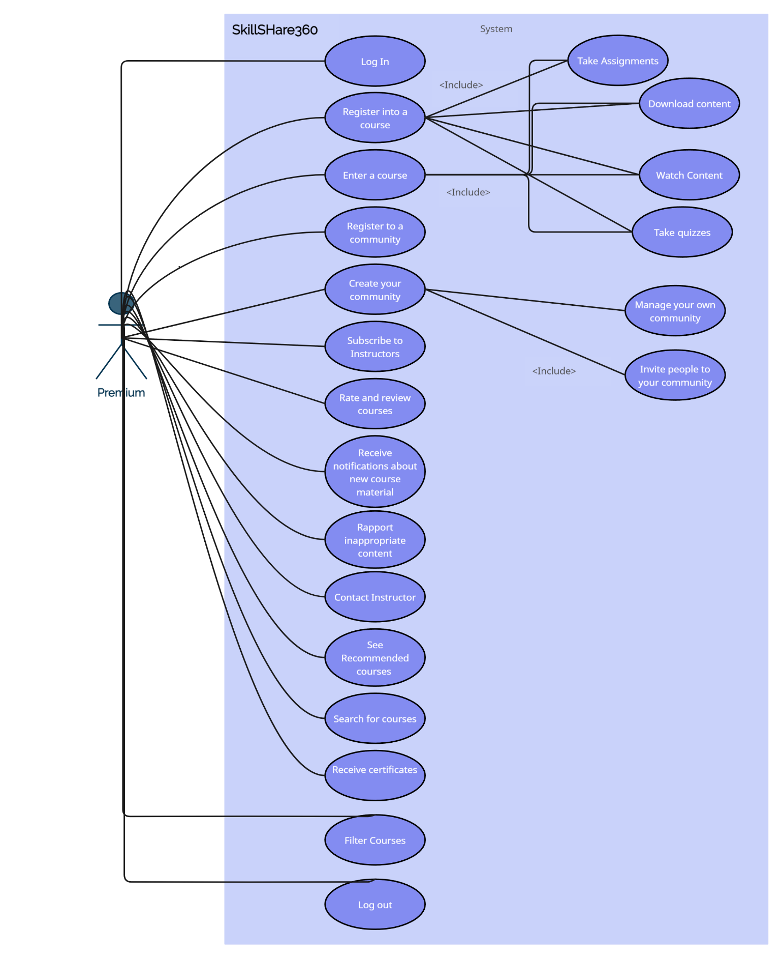

Use Case 3 Instructor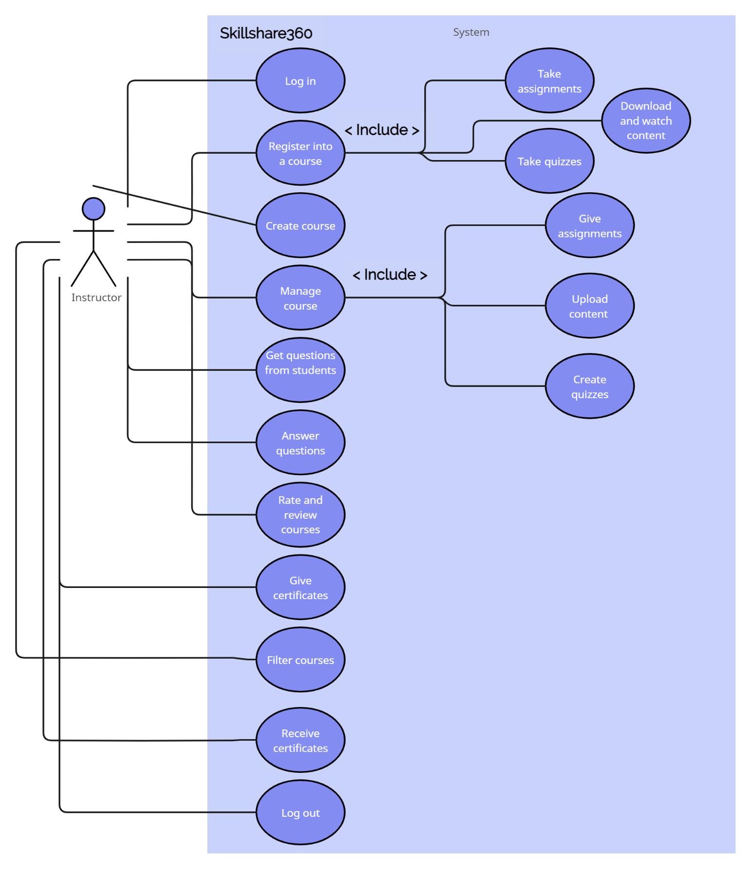

Use Case 4 General

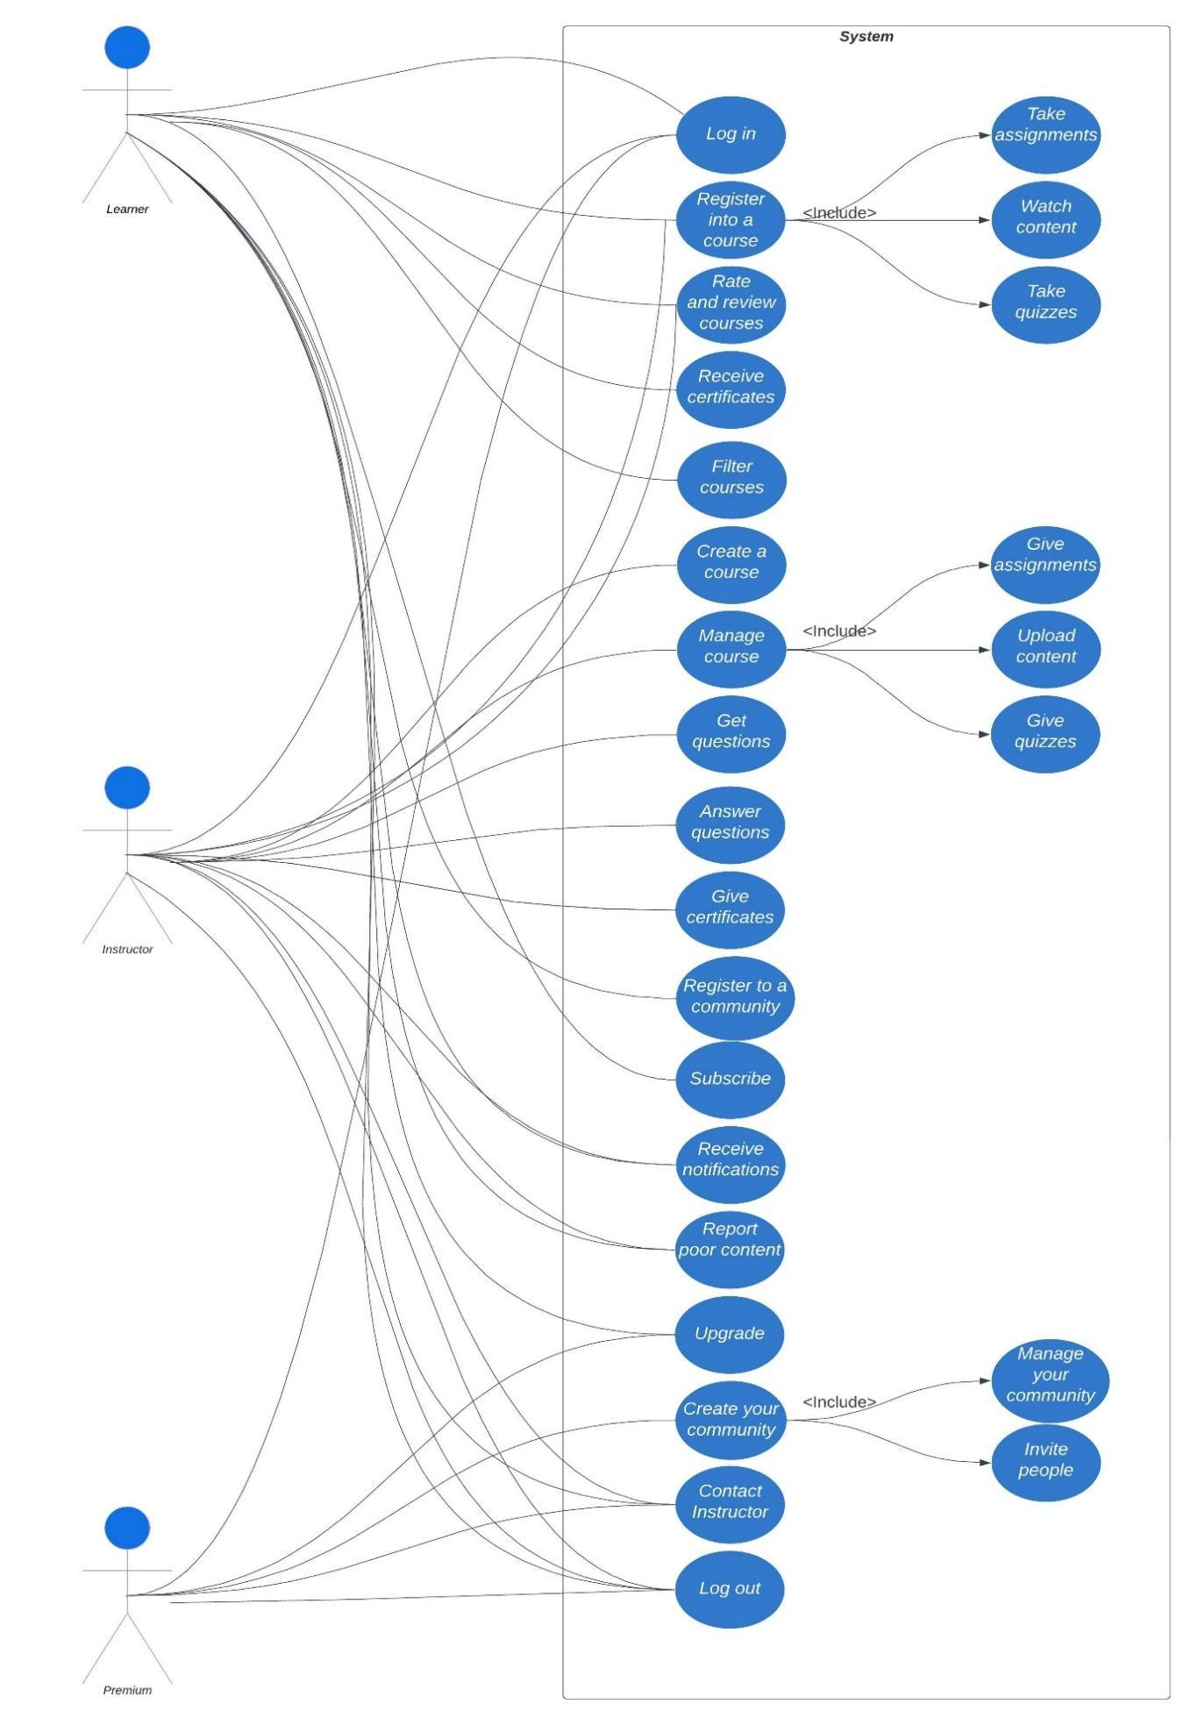

***4.3 Use Cases Extended***

|  |  |
| --- | --- |
| Use Case | Log In |
| Scope: | Skillshare360 |
| Level: | User Level |
| Intention Context: | User has to log in in order to use the services our website provides. |
| Minimum Guarantees: | User marks its data but cannot log in. |
| Success Guarantees: | User logs in successfully after providing the necessary credentials. |
| Primary Actor: | User |
| Stakeholder’s Interest: | To have users who know how to navigate through the website. |
| Precondition: | The user must have a registered account on SkillShare360. |

|  |  |
| --- | --- |
| Use Case | Log out |
| Scope: | Skillshare360 |
| Level: | User level |
| Intention Context: | User logs out after finishing using the website. |
| Minimum Guarantees: | User cannot log out and his access is not protected. |
| Success Guarantees: | User presses the log out button and ends the connection with the website. |
| Primary Actor: | User |
| Stakeholder’s Interest: | If user does not log out, their information may be leaked and used for other operations. |
| Precondition: | The user must be logged in. |

|  |  |
| --- | --- |
| Use Case | Generate Reports |
| Scope: | Skillshare360 |
| Level: | Admin level |
| Intention Context: | Admin generates different reports for statistical and management purposes. |
| Minimum Guarantees: | Admin cannot generate reports. |
| Success Guarantees: | Admin gains access to Admin Panel, and has the option to choose which report he wants to create. |
| Primary Actor: | Admin |
| Stakeholder’s Interest: | By generating different reports, the website keeps track of the activity. |
| Precondition: | Admin has access to Admin panel and can click the button to create different reports. |

|  |  |
| --- | --- |
| Use Case | Register into a course |
| Scope: | Skillshare360 |
| Level: | User level |
| Intention Context: | User chooses a course that he’s interested in. |
| Minimum Guarantees: | The user fails to register into a course. |
| Success Guarantees: | The user successfully joins a course. |
| Primary Actor: | User |
| Stakeholder’s Interest: | The course will be shown in the user’s profile. |
| Precondition: | The user must have chosen one of the three option that the website offers (Learner, Premium, Instructor). |

|  |  |
| --- | --- |
| Use Case | Chooses between Learner, Premium and Instructor |
| Scope: | Skillshare360 |
| Level: | User level |
| Minimum Guarantees: | Not all the necessary information is presented in the website. |
| Success Guarantees: | Detailed services with respective prices. |
| Primary Actor: | User |
| Stakeholder’s Interest: | By presenting all options and prices, everything is more detailed and clearer and also builds trust between website and users. |
| Precondition: | User alternatives and prices have to be posted on the website. |

|  |  |
| --- | --- |
| Use Case | Rate and review courses |
| Scope: | Skillshare360 |
| Level: | User level |
| Intention Context: | User gives his impression of the course. |
| Minimum Guarantees: | The website fails to display the ratings given by the users in the course page. |
| Success Guarantees: | The ratings are displayed. |
| Primary Actor: | User |
| Stakeholder’s Interest: | To provide a transparent impression of the user regarding the rated course. |
| Precondition: | The user must have joined this course at a certain time. |

|  |  |
| --- | --- |
| Use Case | Take quizzes or assignments |
| Scope: | Skillshare360 |
| Level: | User level |
| Intention Context: | User picks an assignment or a quiz that he wants to solve |
| Minimum Guarantees: | User doesn’t solve it. |
| Success Guarantees: | User solves the given task and then checks his work with the correct solution of the task. |
| Primary Actor: | User |
| Stakeholder’s interest: | The user can check his progress with the course. |
| Precondition: | User should be a member of the course that generates this quizzes or assignments. |

|  |  |
| --- | --- |
| Use Case | Enter a course |
| Scope: | Skillshare360 |
| Level: | User level |
| Intention Context: | User enters in one of the courses that he is registered. |
| Minimum Guarantees: | User isn’t registered in any course so he can’t access the materials. |
| Success Guarantees: | User enters and the materials of that course are displayed. |
| Primary Actor: | User |
| Stakeholder’s interest: | The materials of the course are displayed and are easily navigated by the users. |
| Precondition: | User must be registered in a course in order to access its materials. |

|  |  |
| --- | --- |
| Use Case | Create a community |
| Scope: | Skillshare360 |
| Level: | Premium level |
| Intention Context: | Premium users can create and manage their own community. |
| Minimum Guarantees: | The user that created it will be the only one in that community. |
| Success Guarantees: | Many users will join the community. |
| Primary Actor: | Premium User |
| Stakeholder’s interest: | Creating a community which will help the users socialize and better refine the skills that they learn in this website by interacting with each other. |
| Precondition: | Only a Premium user can create a community. |

|  |  |
| --- | --- |
| Use Case | Create course |
| Scope: | Skillshare360 |
| Level: | User level |
| Minimum Guarantees: | Instructor fails to create course. |
| Success Guarantees: | Instructor successfully creates course. |
| Primary Actor: | Instructor |
| Stakeholder’s Interest: | The course created to be of high-quality and understandable. |
| Precondition: | The creator of the course must be an Instructor. |

|  |  |
| --- | --- |
| Use Case | Register in a community |
| Scope: | Skillshare360 |
| Level: | User level |
| Minimum Guarantees: | User finds the community he wants to join, but doesn’t register. |
| Success Guarantees: | User successfully registers. |
| Primary Actor: | User |
| Stakeholder’s Interest: | To have communities that are easily accessible by everyone. |
| Precondition: | User must be a Learner, Premium user or Instructor. |

|  |  |
| --- | --- |
| Use Case | Add/Update/Delete services |
| Scope: | Skillshare360 |
| Level: | Admin level |
| Intention Context: | The admin adds, updates or deletes services offered by the website.  (Admin – Our team) |
| Minimum Guarantees: | Admin cannot access his tools. |
| Success Guarantees: | Admin gains access, and has the option to create, update or delete the services offered by the website. |
| Primary Actor: | Admin |
| Stakeholder’s Interest: | The services of the website are updated by the admin. |
| Precondition: | Admin logs in. |

|  |  |
| --- | --- |
| Use Case | Give certificates |
| Scope: | Skillshare360 |
| Level: | Instructor level |
| Intention Context: | Providing users of a certain course with a certificate. |
| Minimum Guarantees: | Instructor fails to provide users with a certificate. |
| Success Guarantees: | Instructor gives a certificate to every user who has earned it. |
| Primary Actor: | Instructor |
| Stakeholder’s Interest: | To notify users that they have finished and passed the course. |
| Precondition: | Instructor logged in. |

|  |  |
| --- | --- |
| Use Case | Receive certificates |
| Scope: | Skillshare360 |
| Level: | User level |
| Intention Context: | Providing users of a certain course with a certificate. |
| Minimum Guarantees: | User doesn’t claim his certificate. |
| Success Guarantees: | User is provided with his certificate. |
| Primary Actor: | User |
| Stakeholder’s Interest: | To receive the certificate so that he can prove the finalization of the course. |
| Precondition: | User logged in. |

|  |  |
| --- | --- |
| Use Case | Download content |
| Scope: | Skillshare360 |
| Level: | User level |
| Intention Context: | Downloading content provided by instructor. |
| Minimum Guarantees: | Materials cannot be downloaded. |
| Success Guarantees: | User successfully downloads the materials. |
| Primary Actor: | User |
| Stakeholder’s Interest: | To download material that can be watched and learned offline later on. |
| Precondition: | User logged in and present in the course’s page. |

|  |  |
| --- | --- |
| Use Case | Upload content |
| Scope: | Skillshare360 |
| Level: | Instructor level |
| Intention Context: | Uploading content related to the course. |
| Minimum Guarantees: | Uploading fails. |
| Success Guarantees: | Instructor successfully uploads the materials. |
| Primary Actor: | Instructor |
| Stakeholder’s Interest: | To upload material that is of high quality and related to the course. |
| Precondition: | Instructor logged in and present in the course’s page. |

***4.4 BPMN***

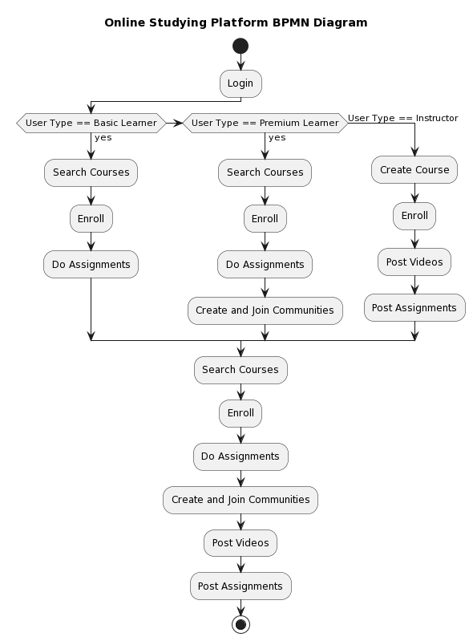

***4.5 Data flow diagrams***

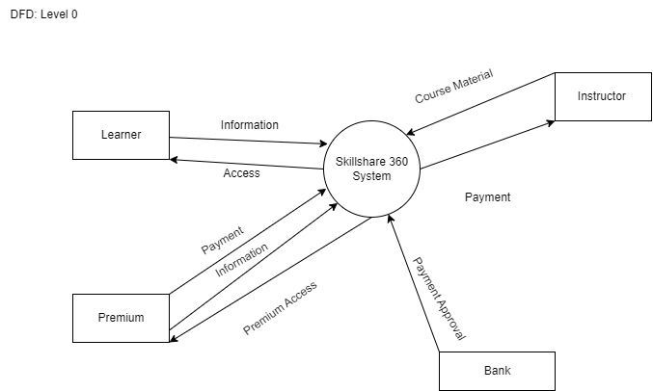

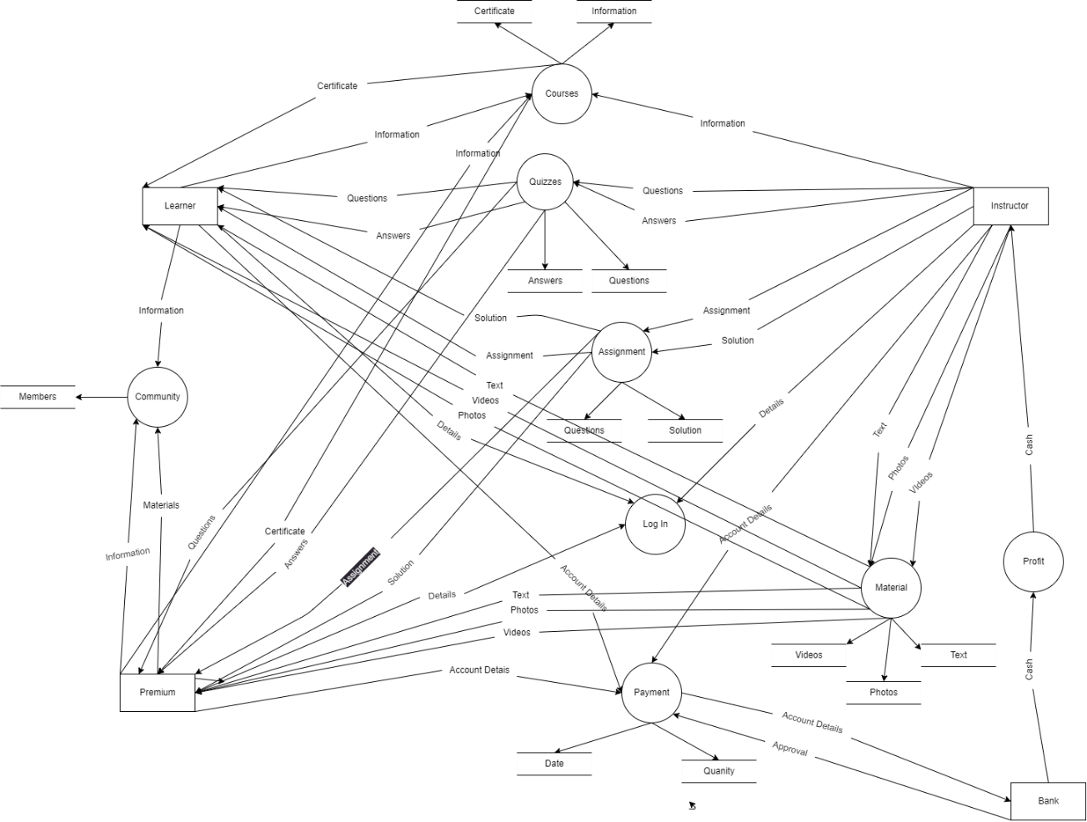

**Community DFD**

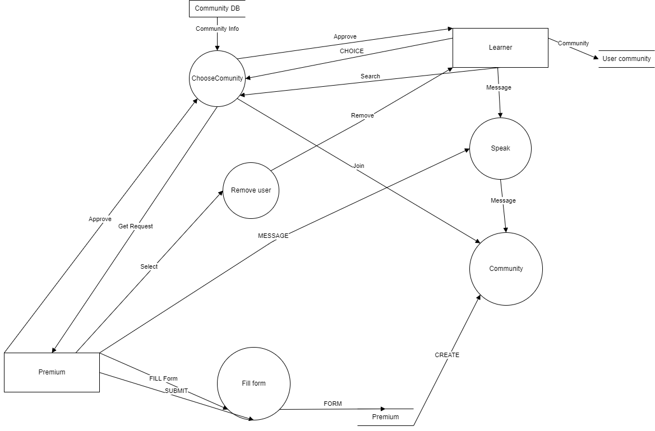

**Contact Instructor**

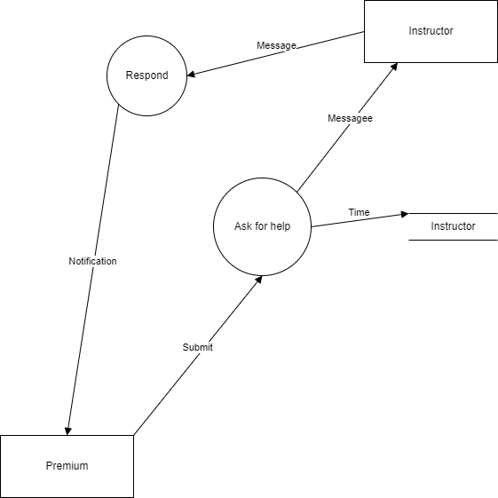

**Payment DFD**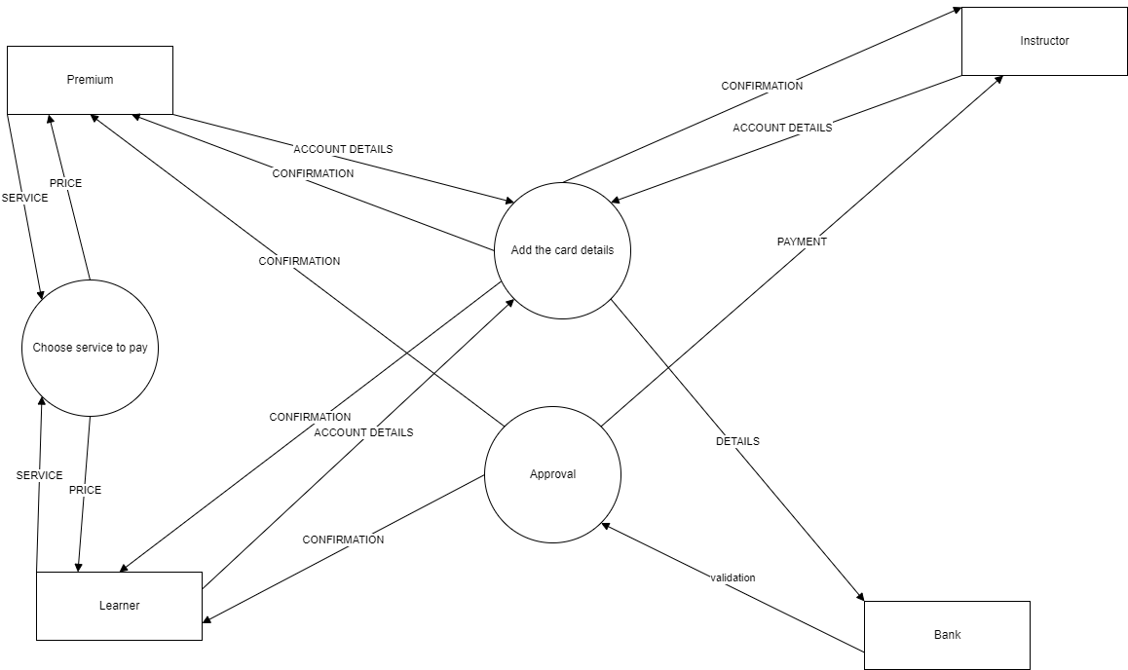

**Course**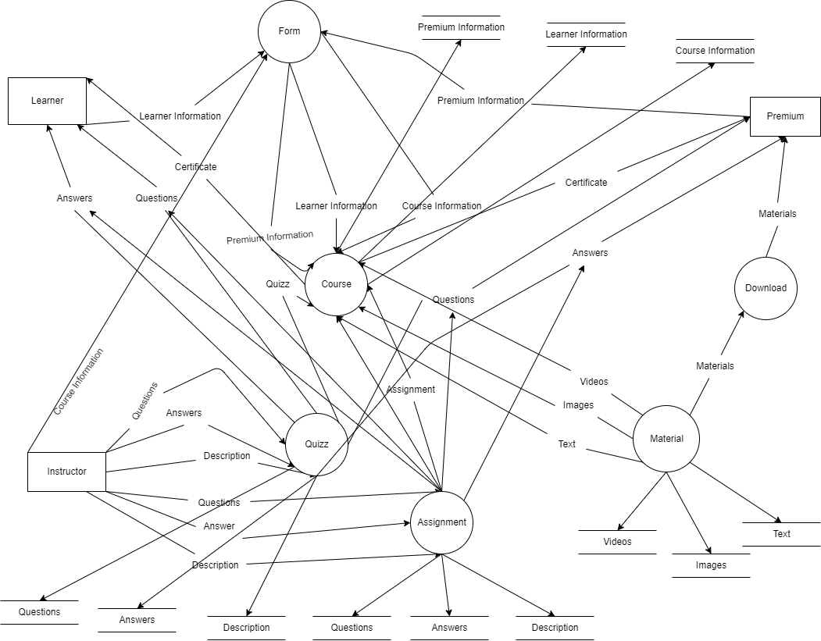

***4.6 Entity-Relation (ERD)***

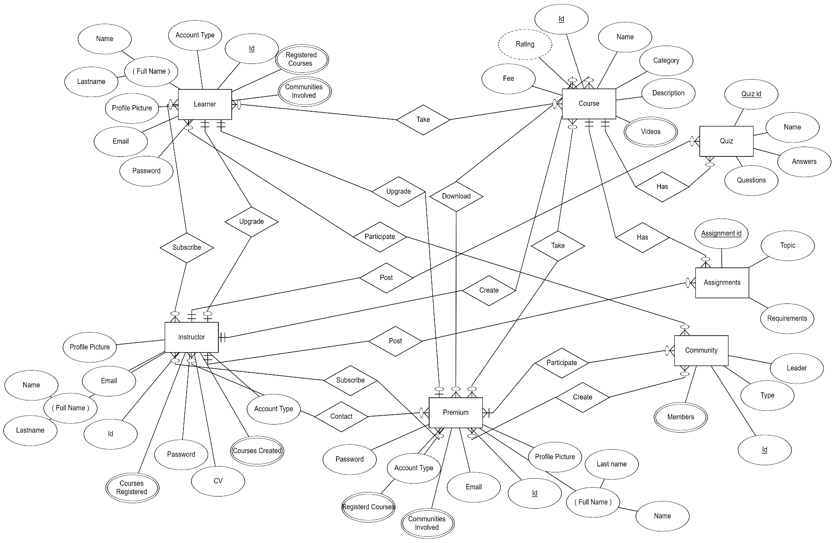

***4.7 Activity Diagrams***

#01 Log In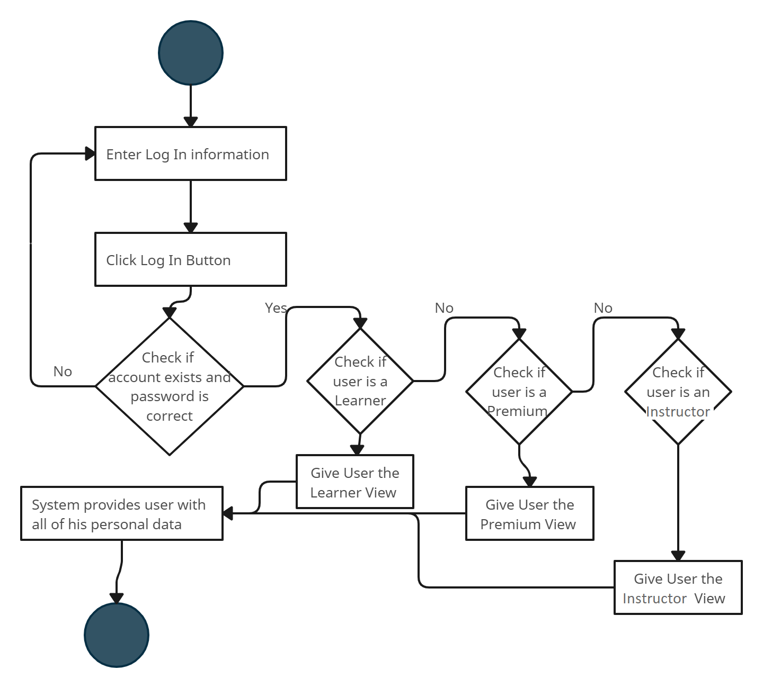

#02 Sign Up

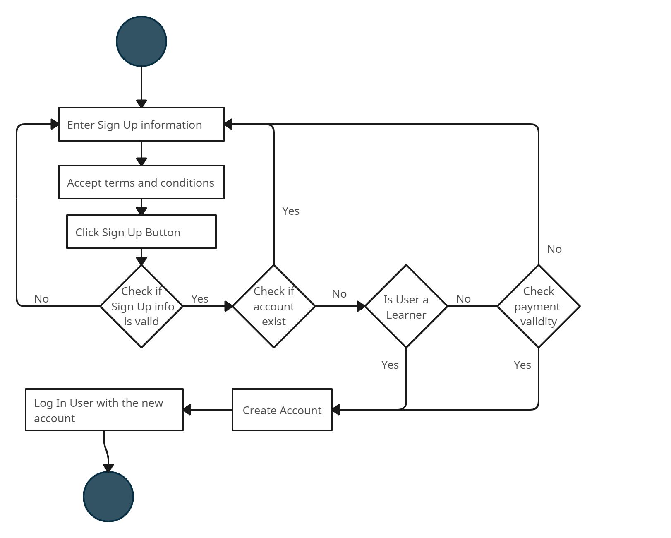

#03 Create Course

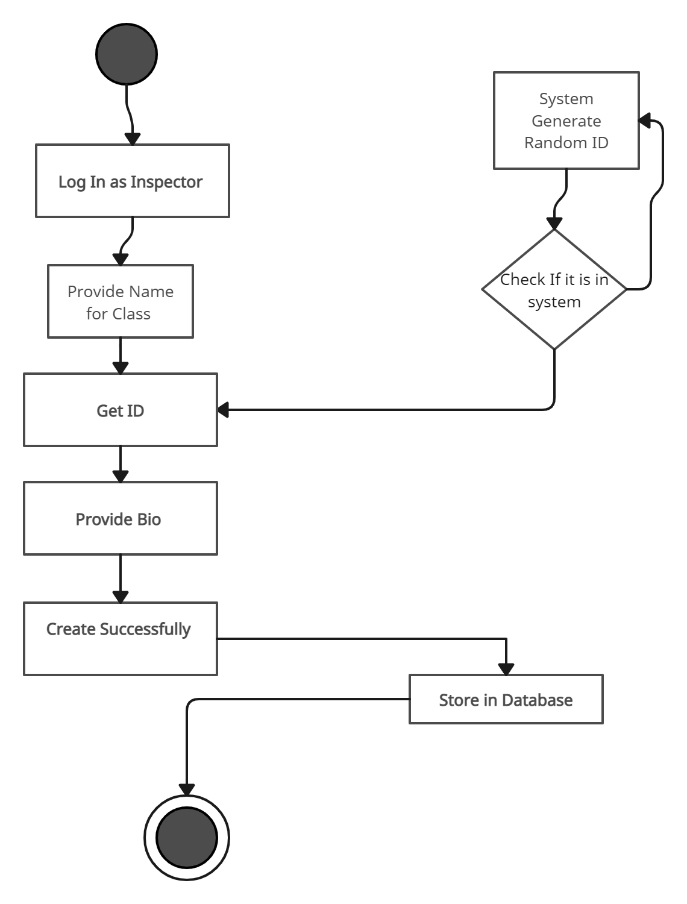

#04 Register Course

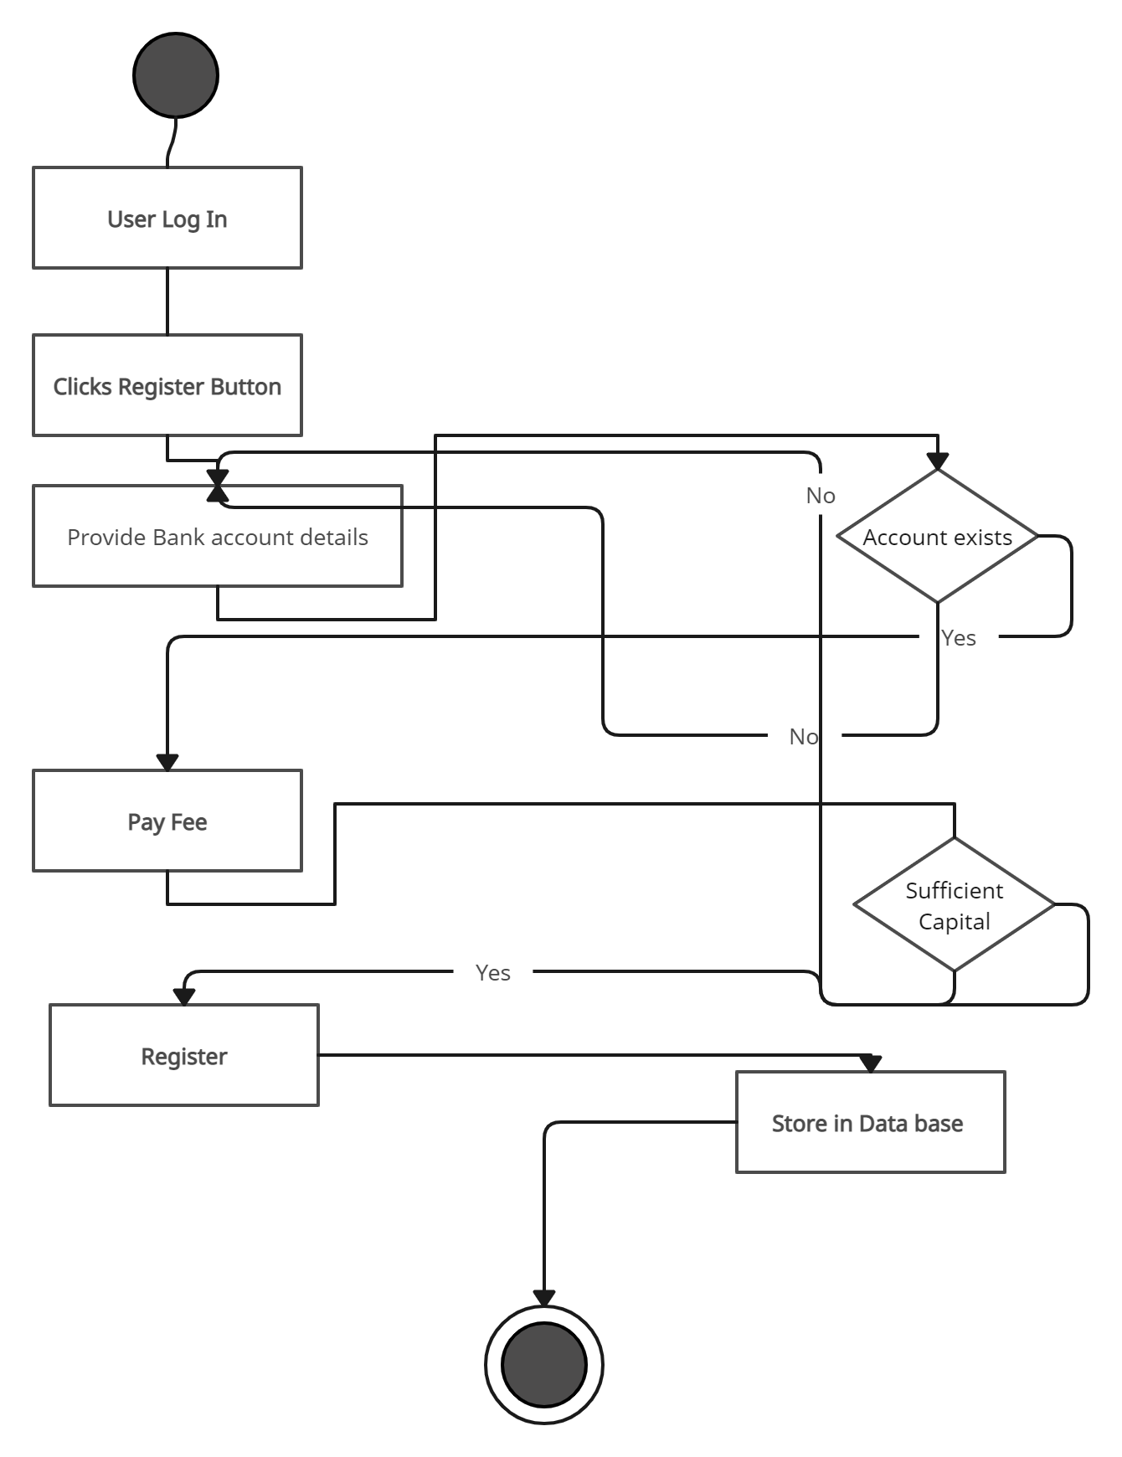

#05 Rate Course

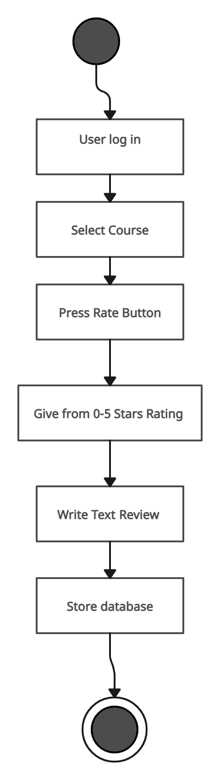

#06 Premium Creates Community

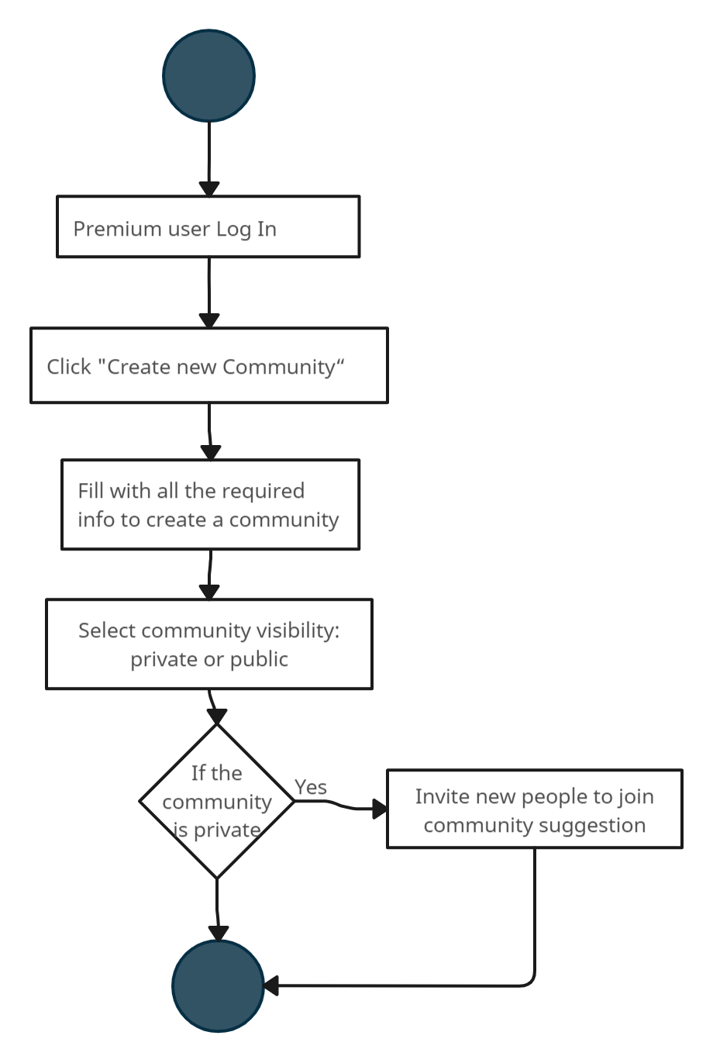

#07 User joins community

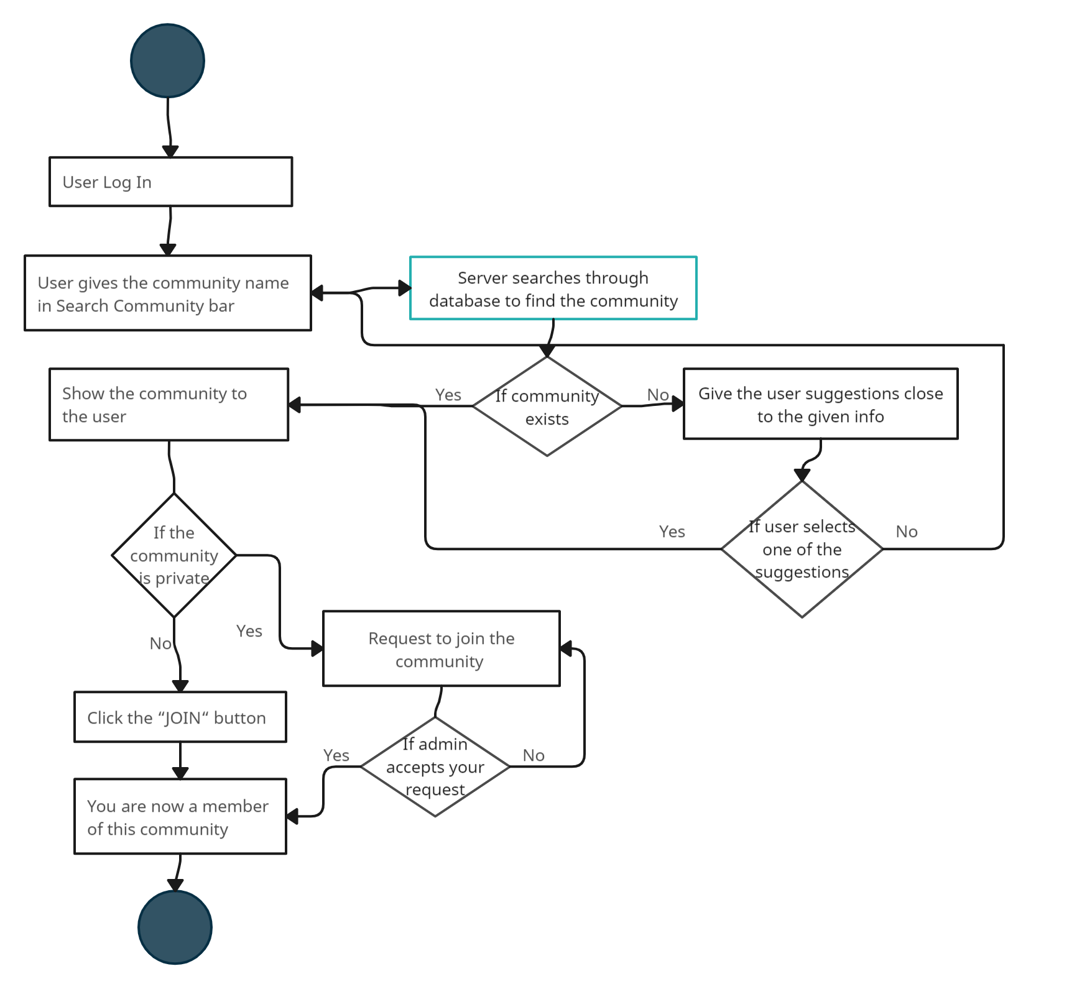

#08 Instructor adds materials

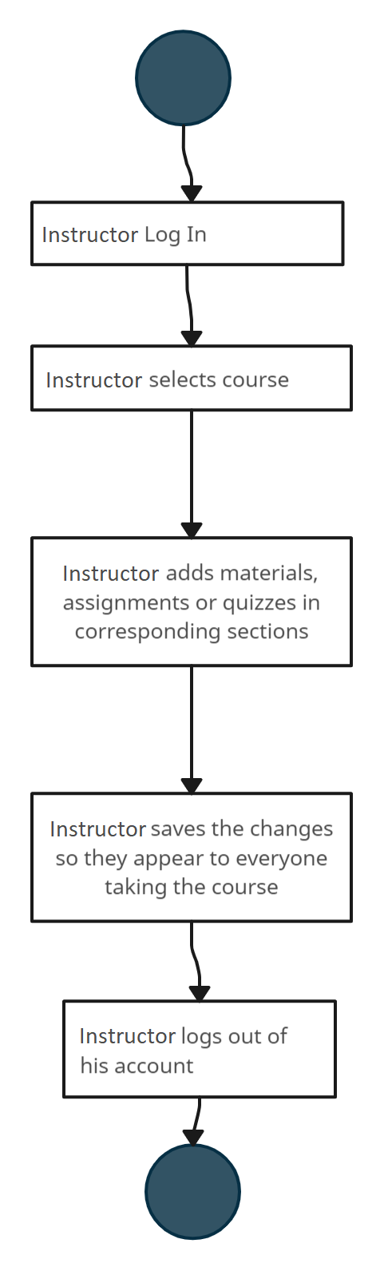

#09 Submit Question

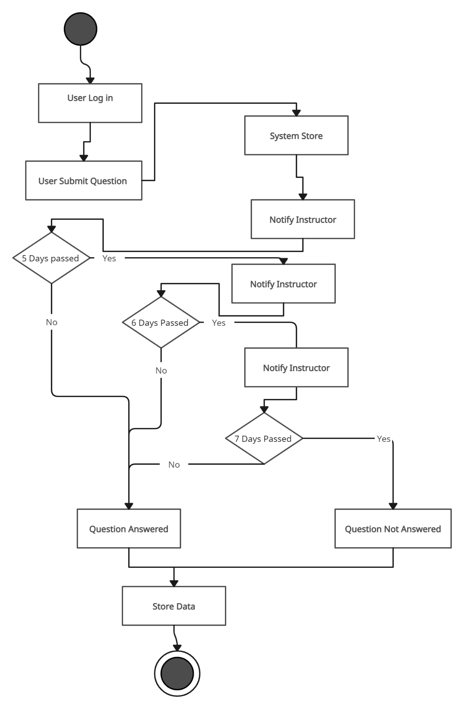

#10 User Takes Quiz

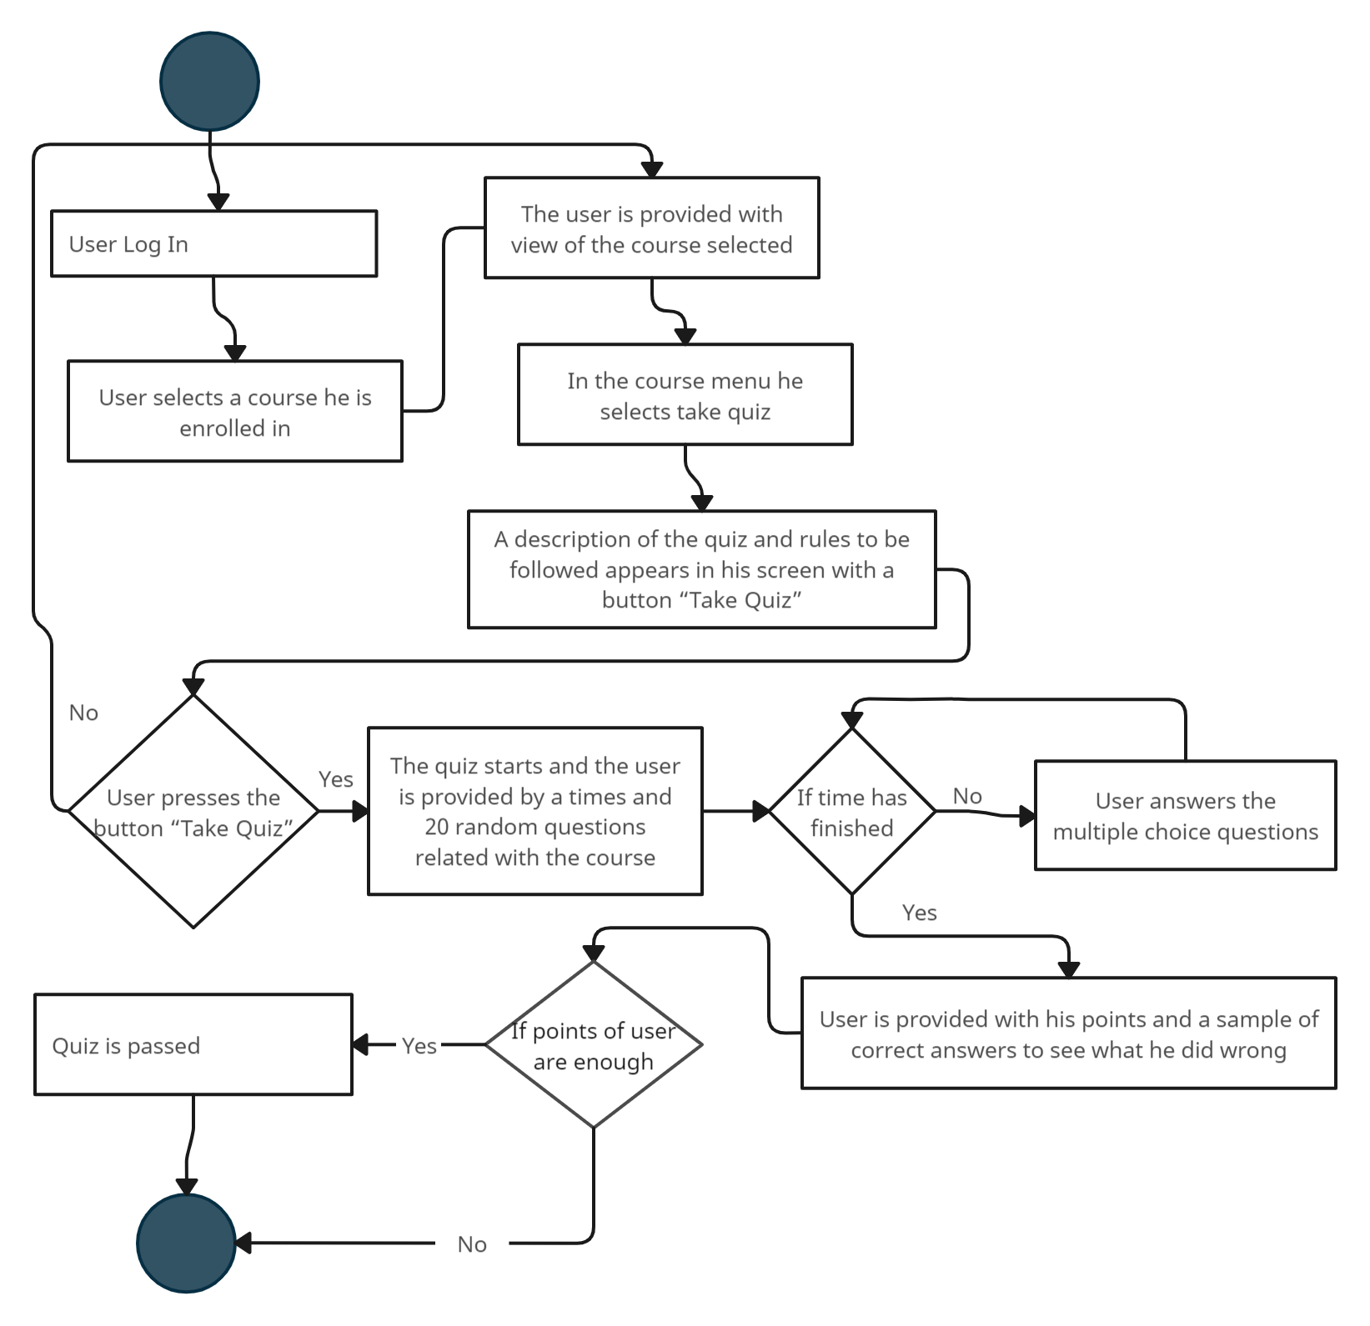

#11 Online Certificate

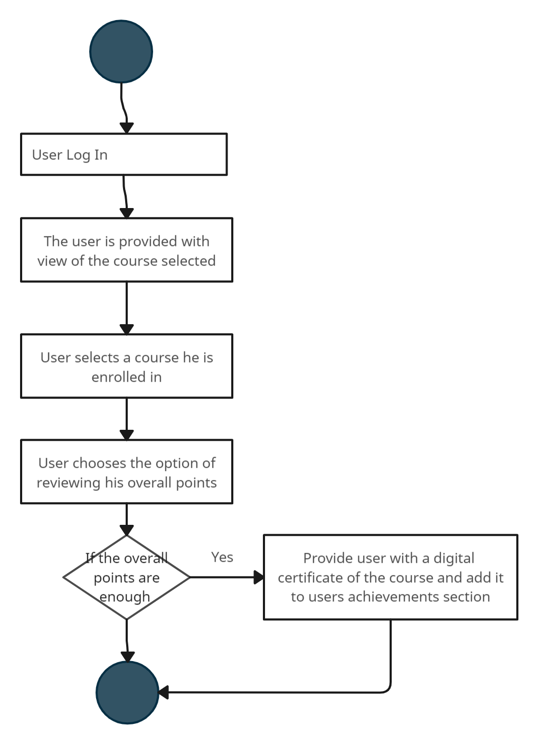

#13 Report Content

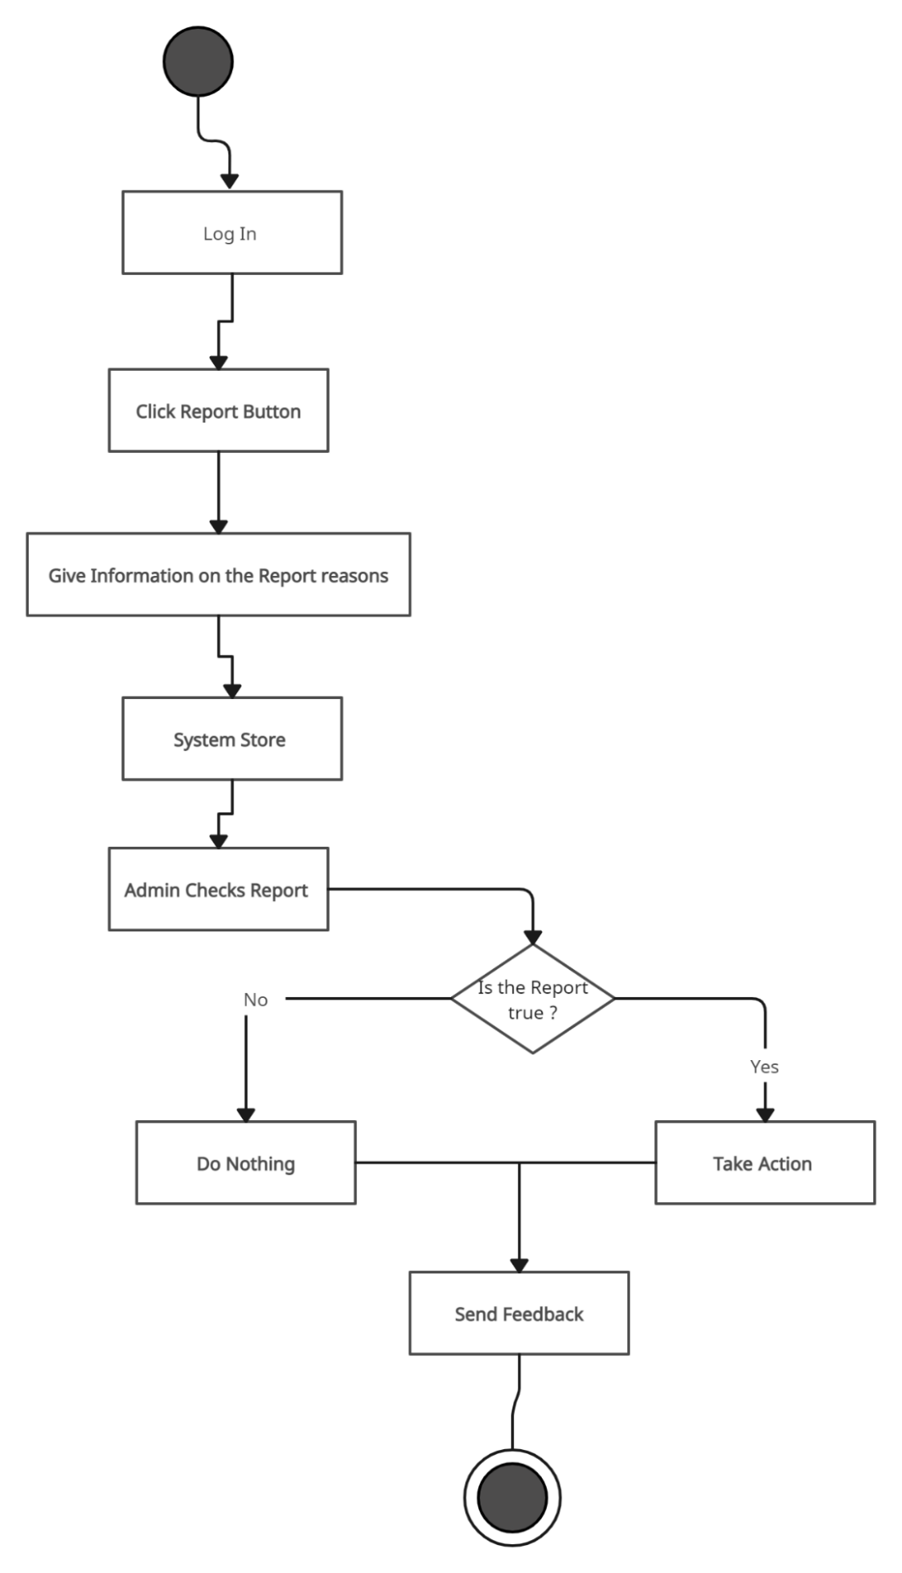

#14 Recommendation

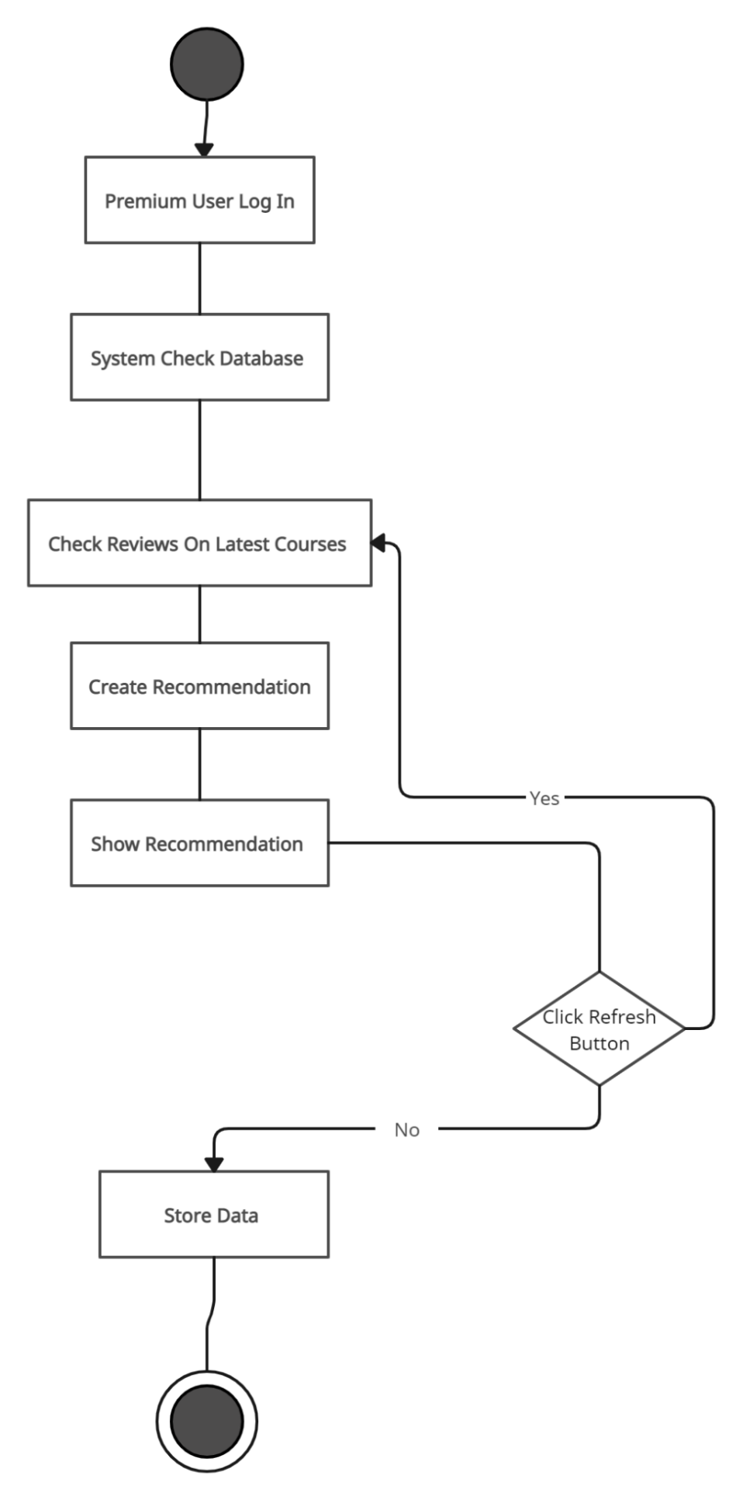

***4.8 State Diagrams***

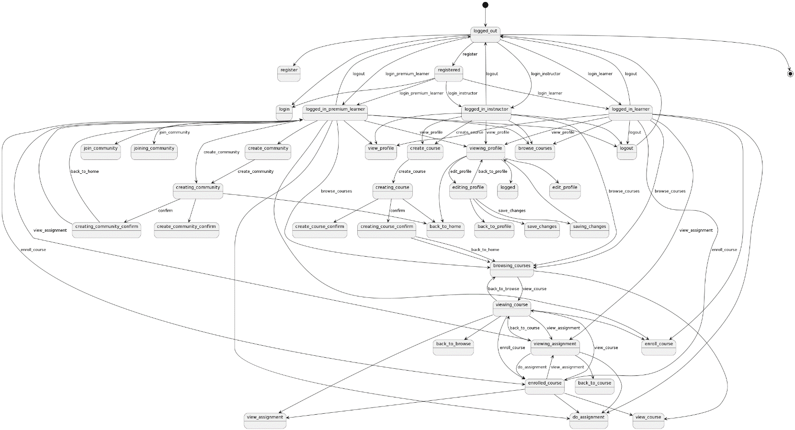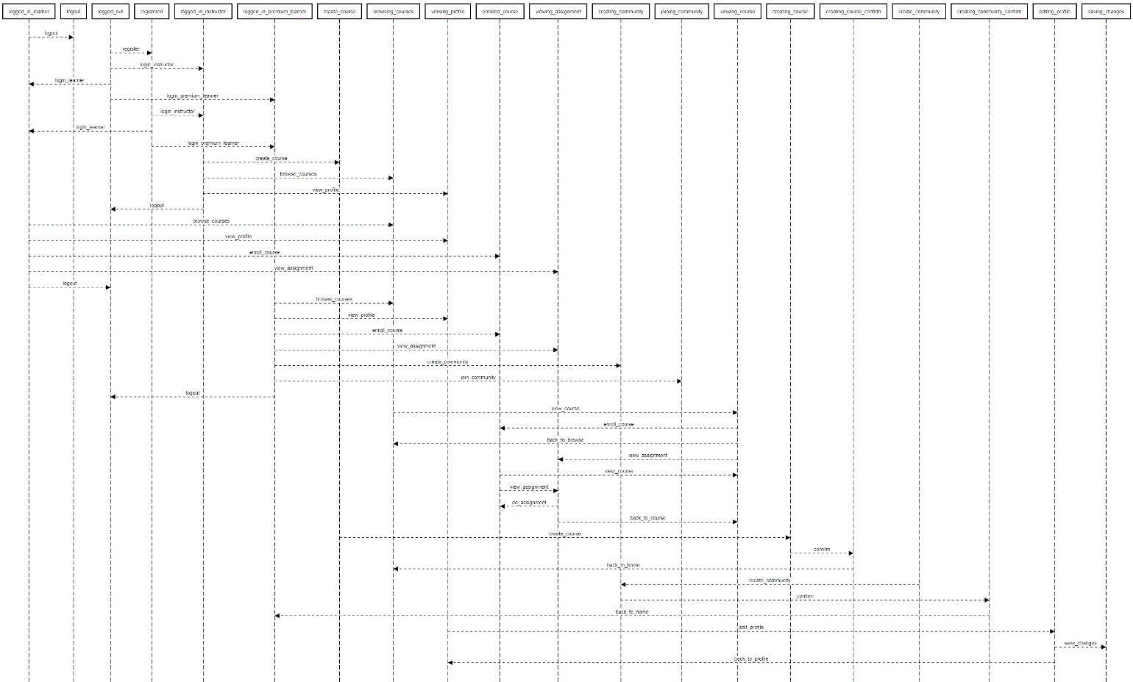

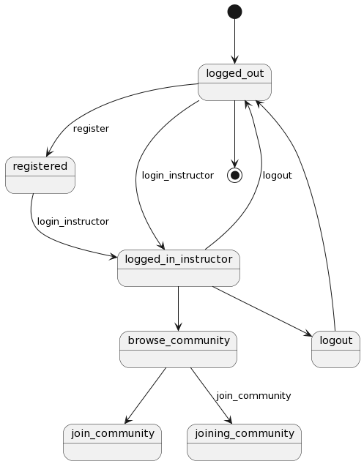

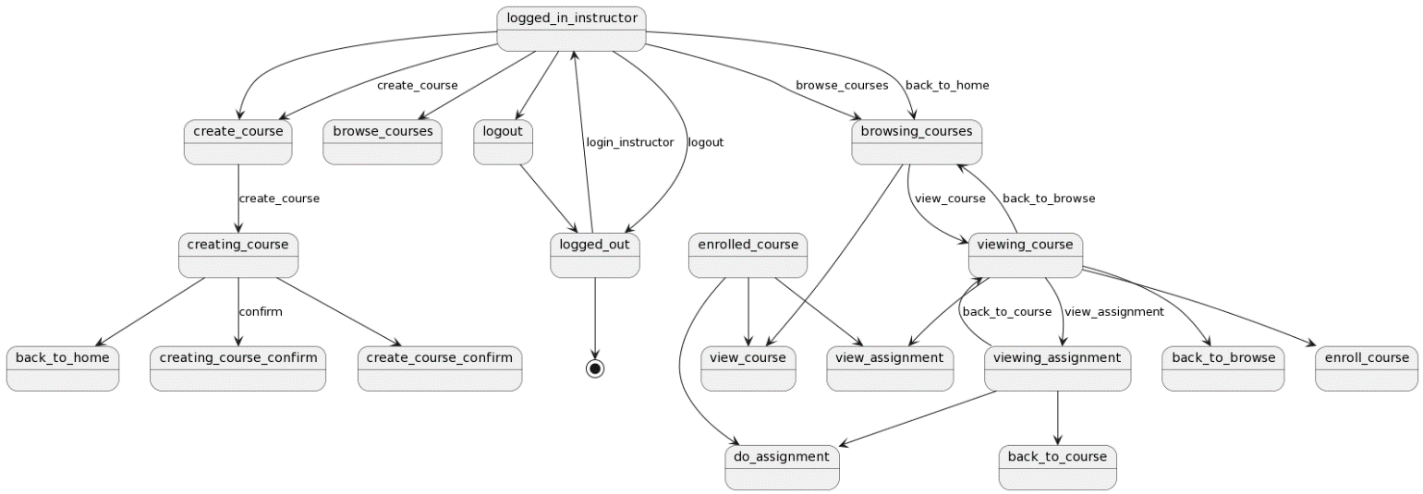

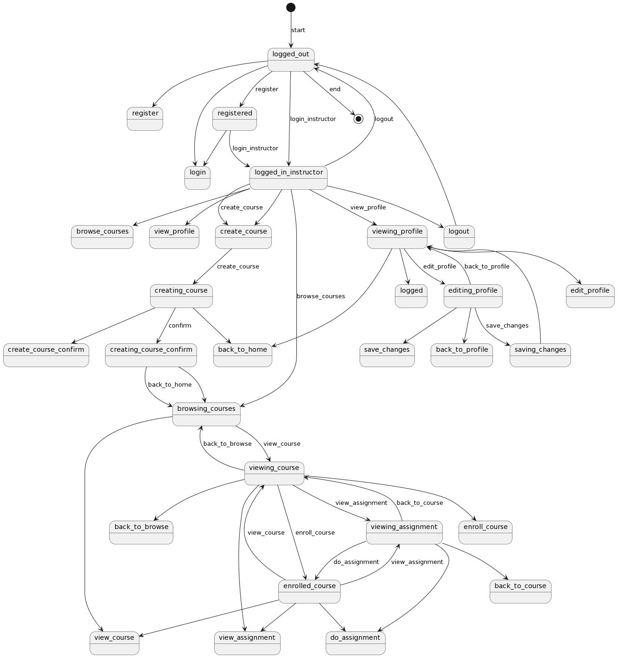

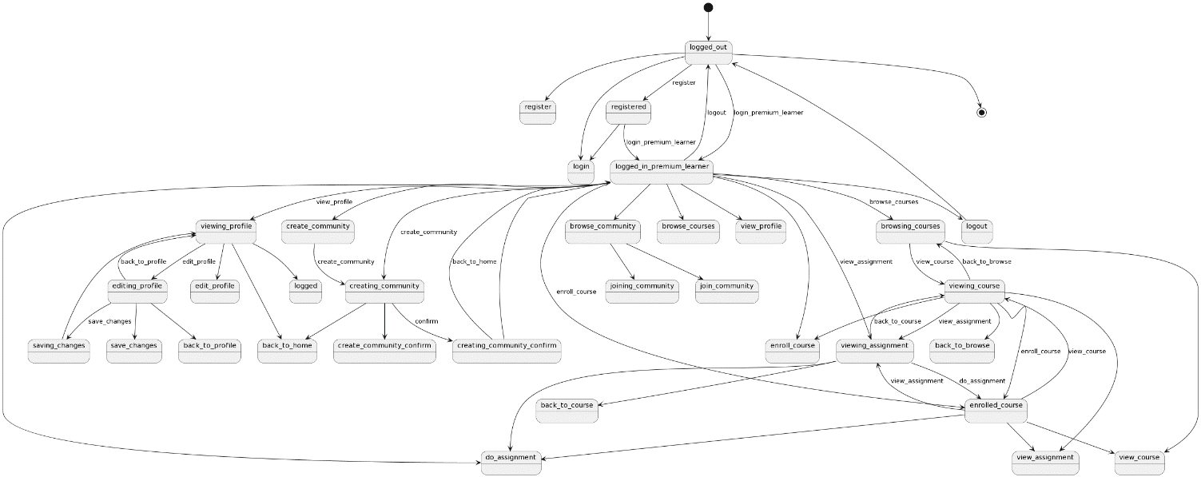

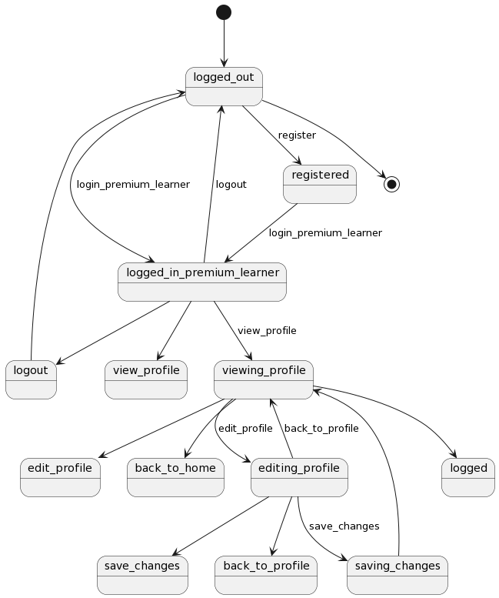

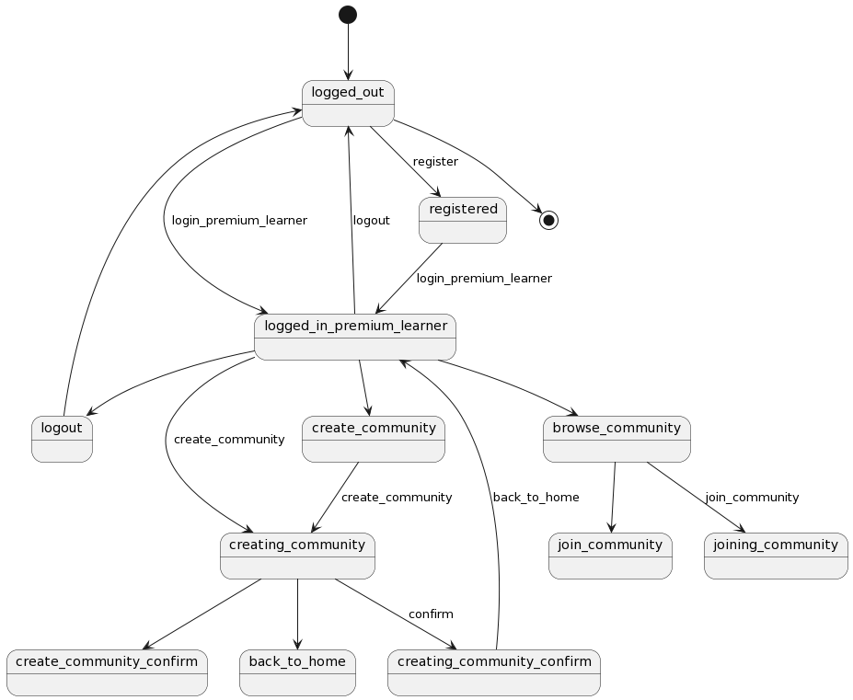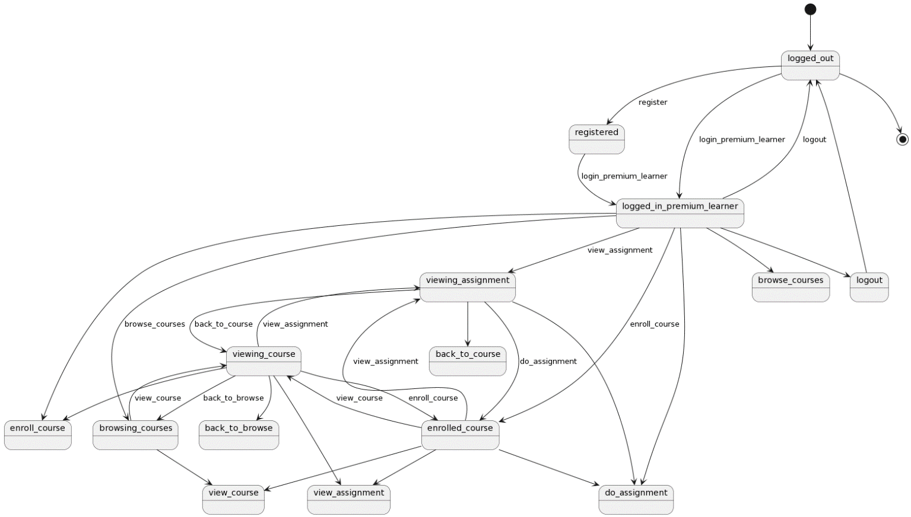

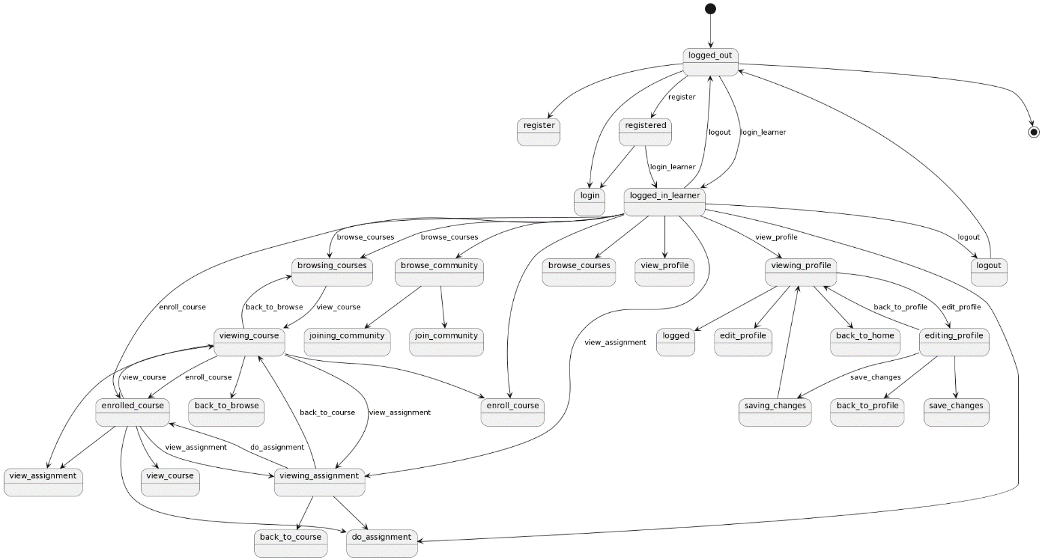

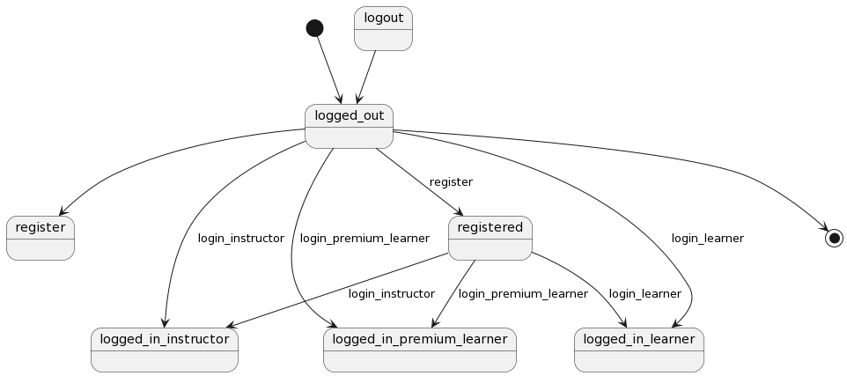

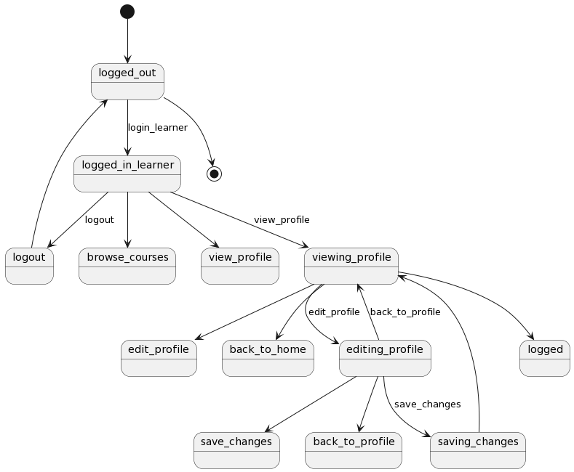

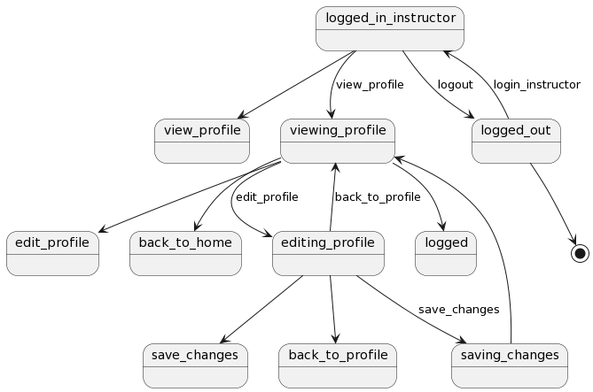

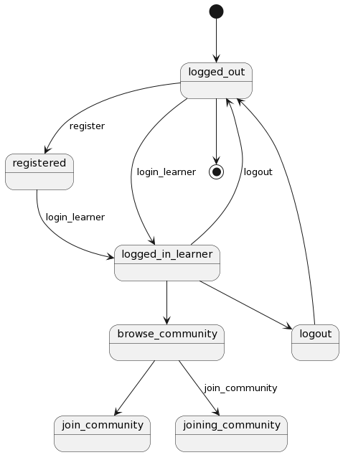

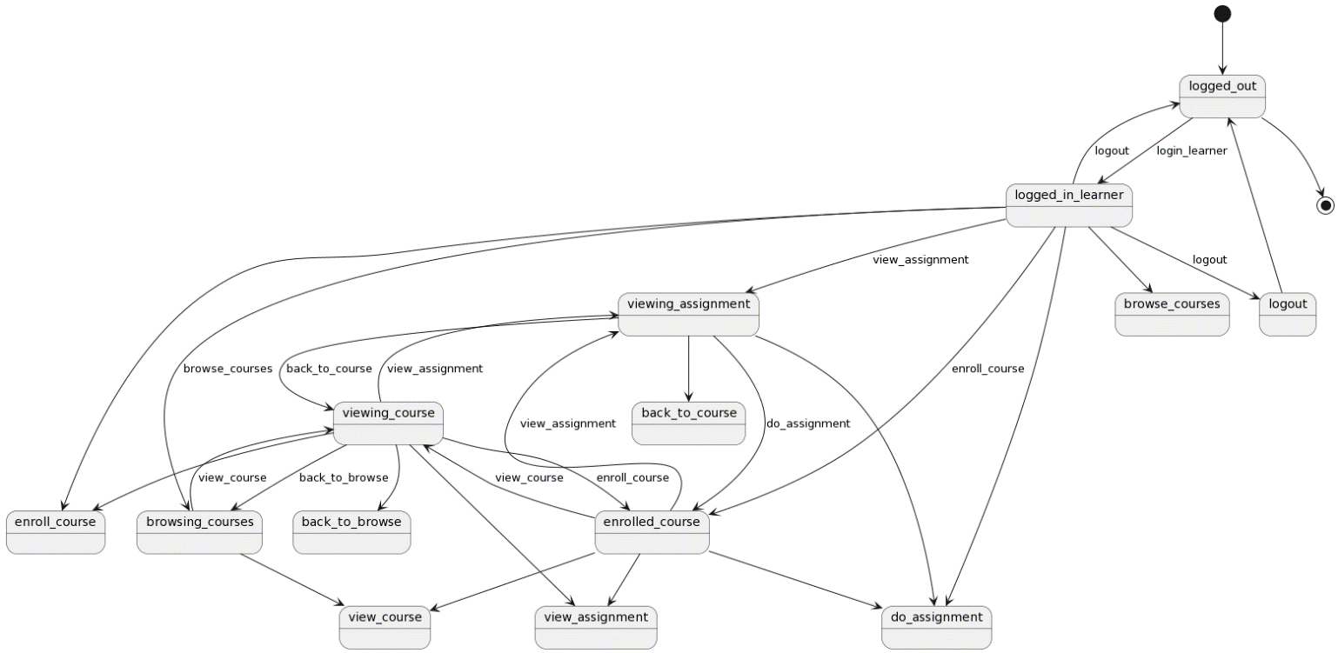

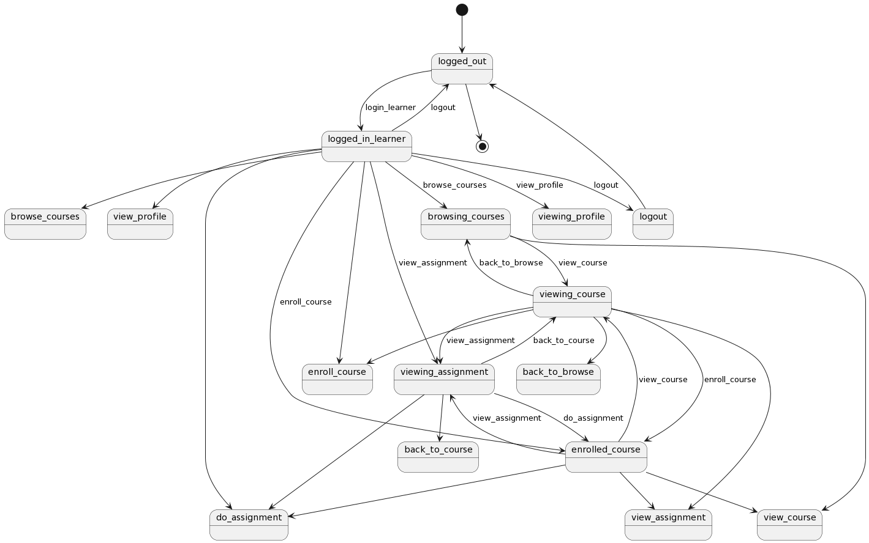

##### 4.10 Sequence diagrams

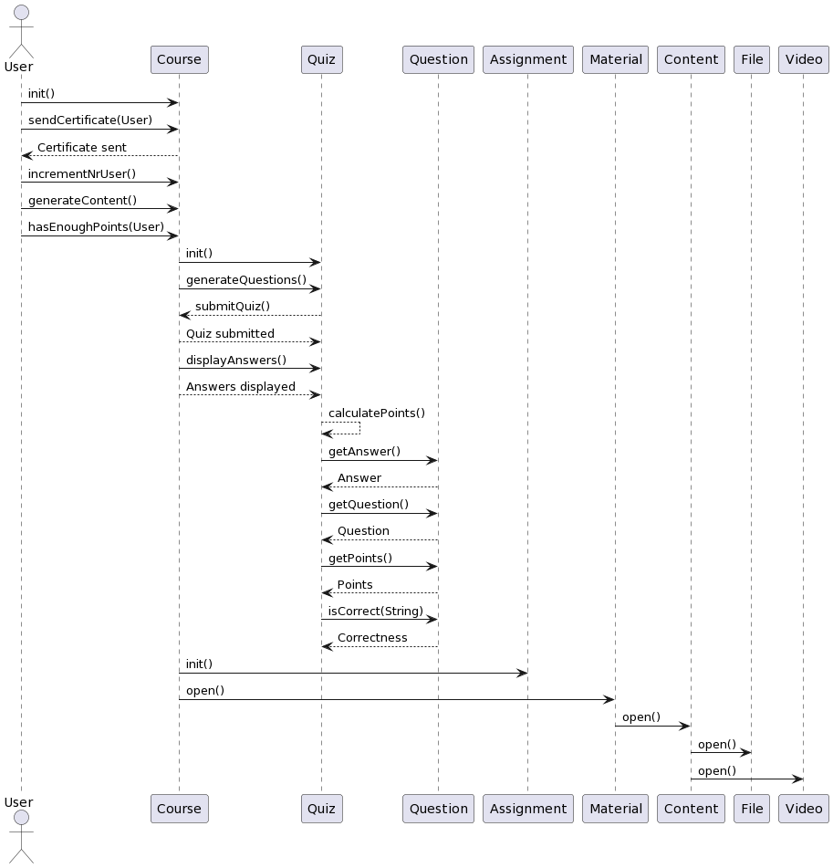

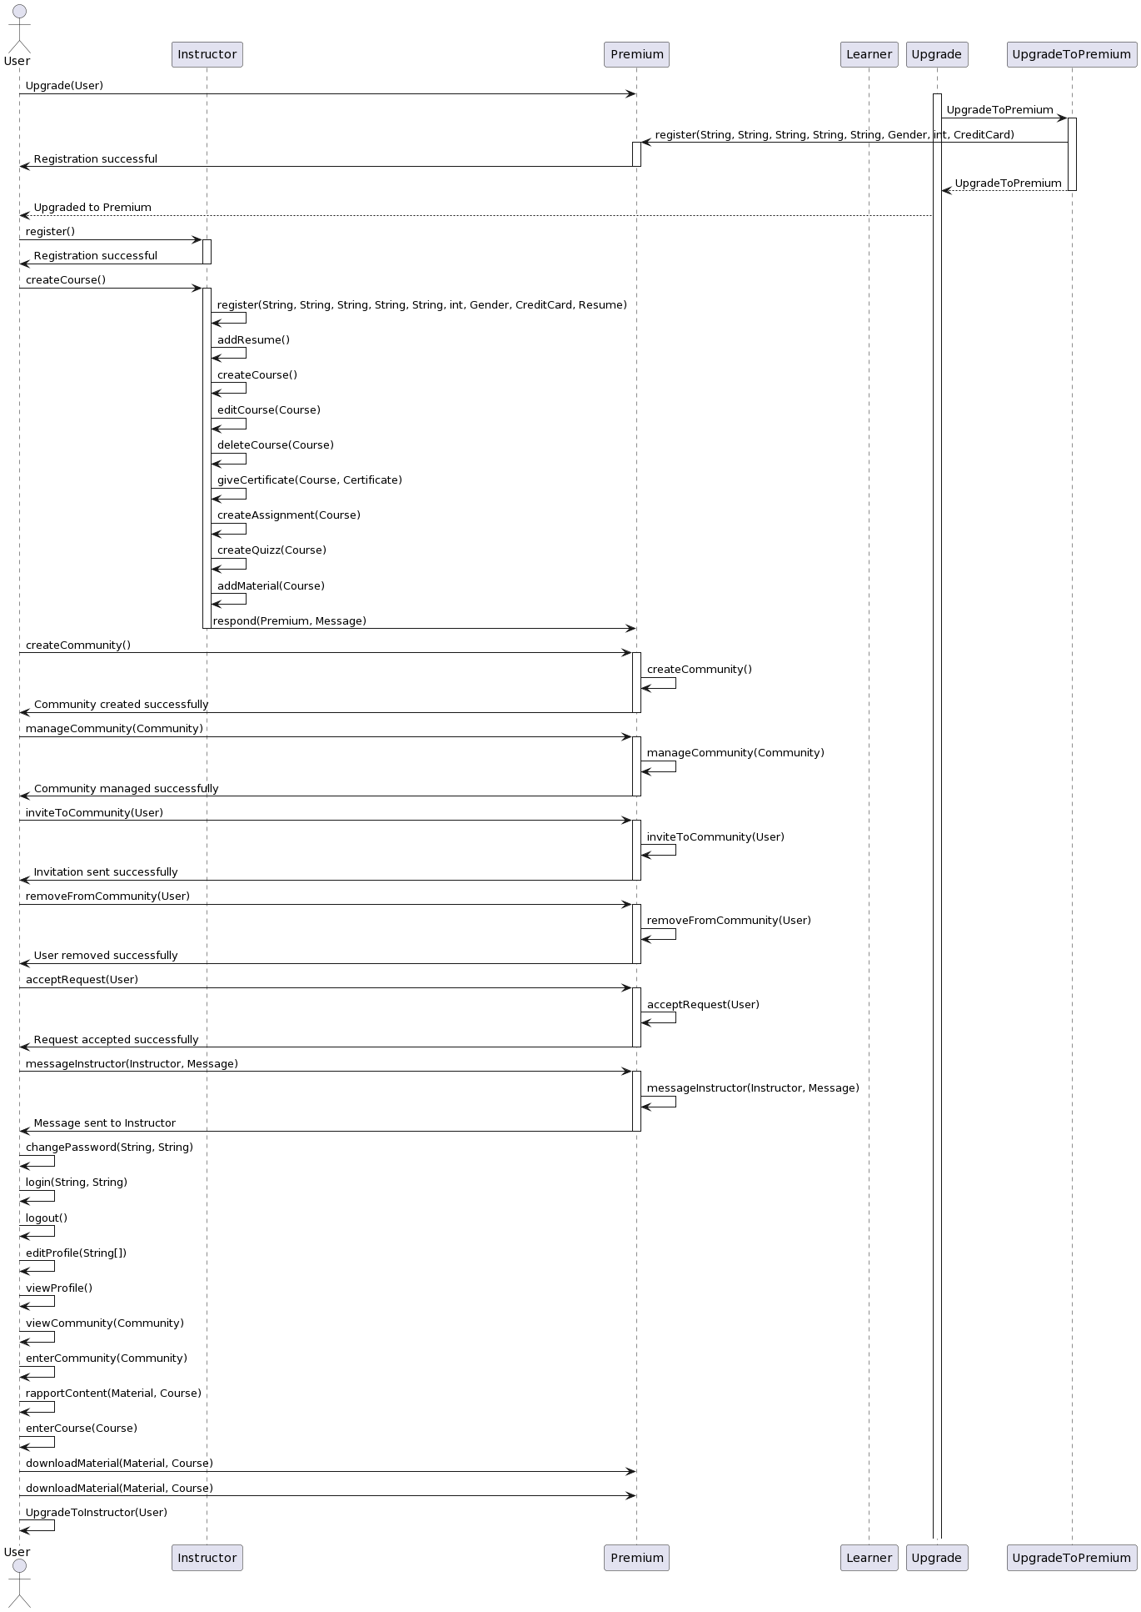

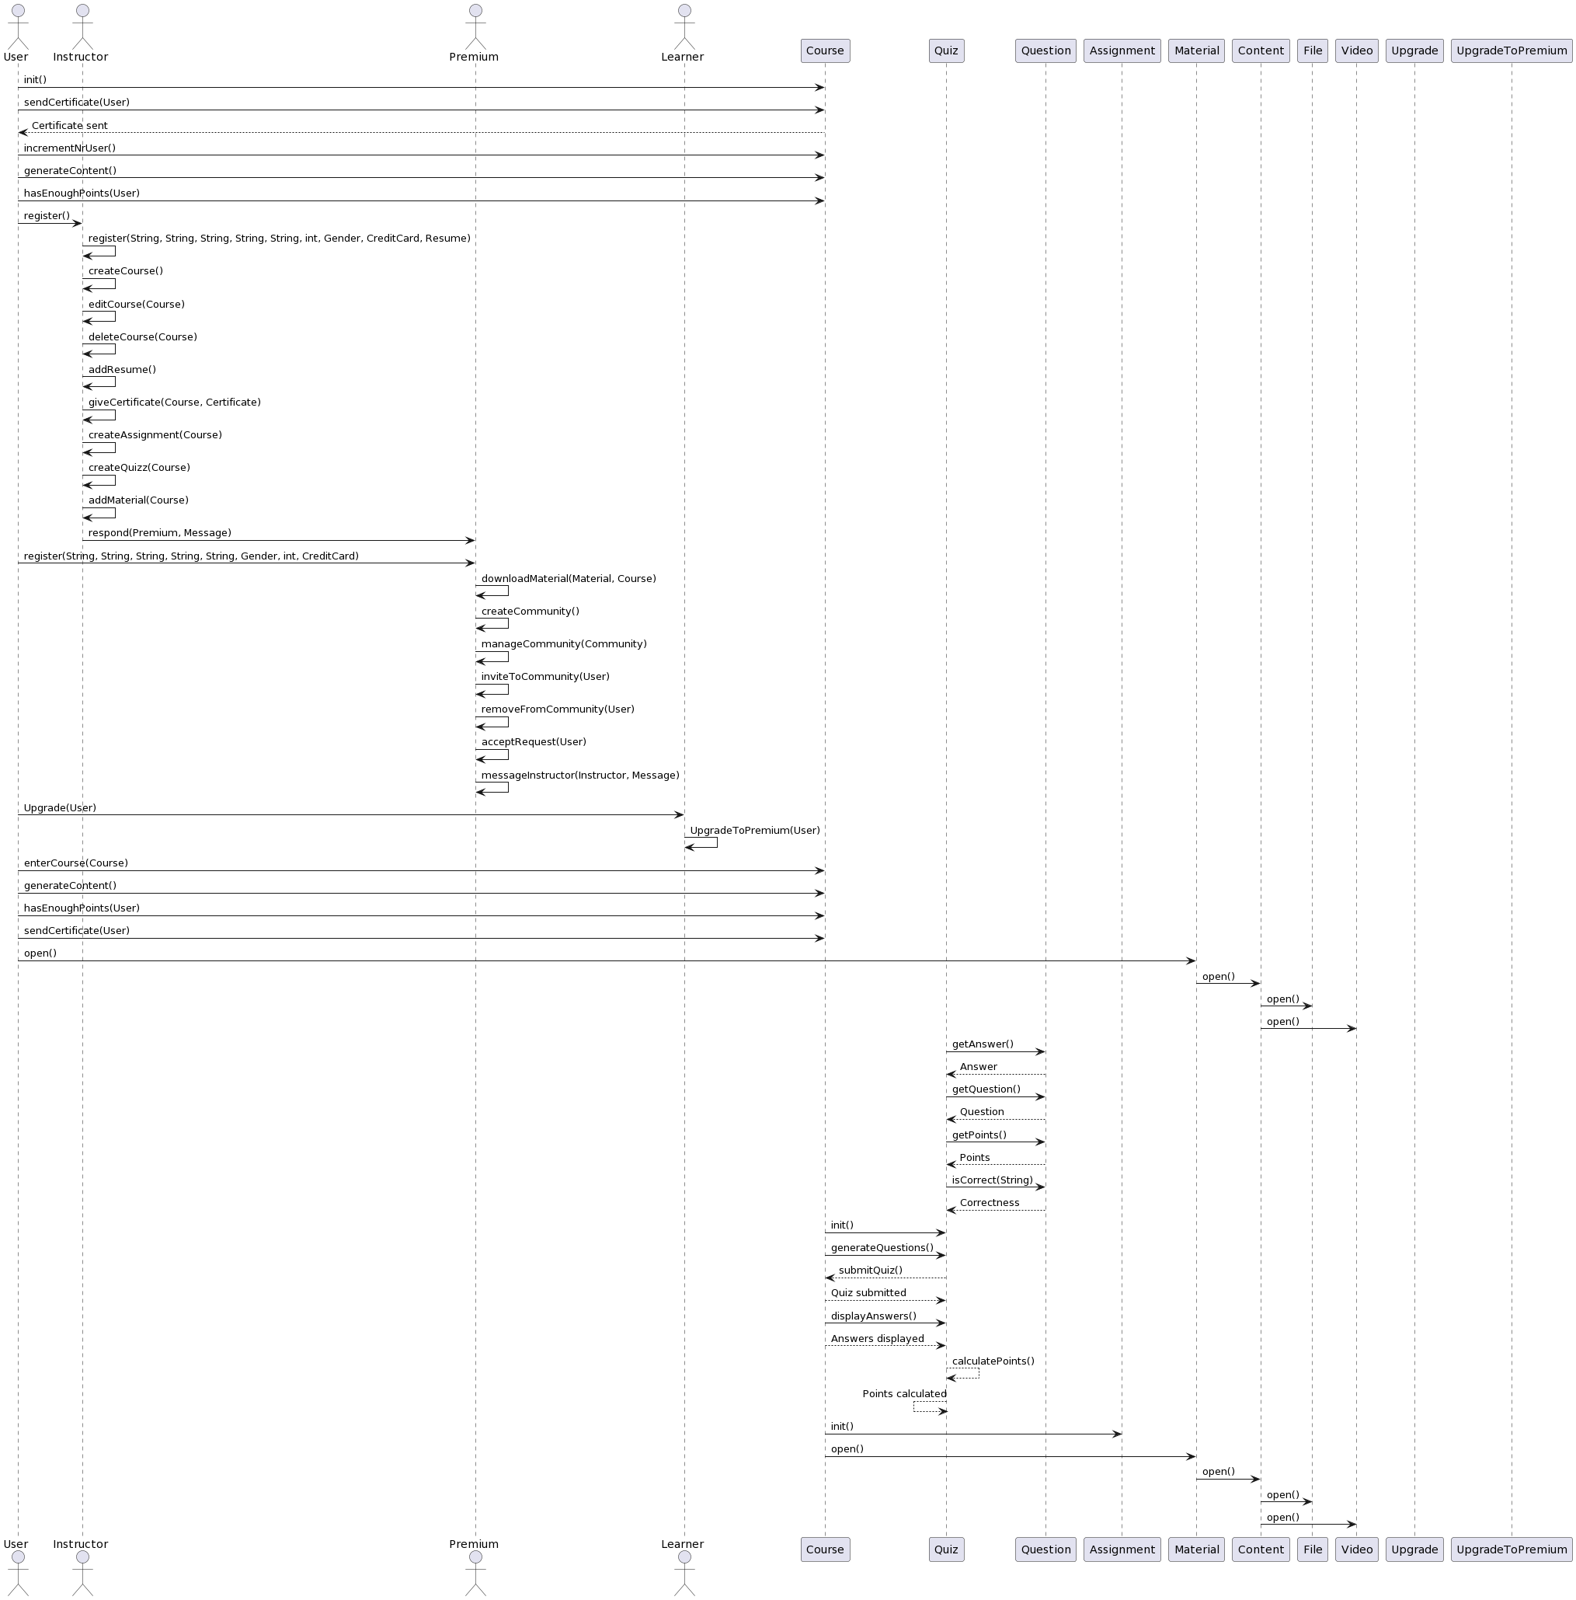

***4.12 Class Diagrams***

***General Class Diagram***

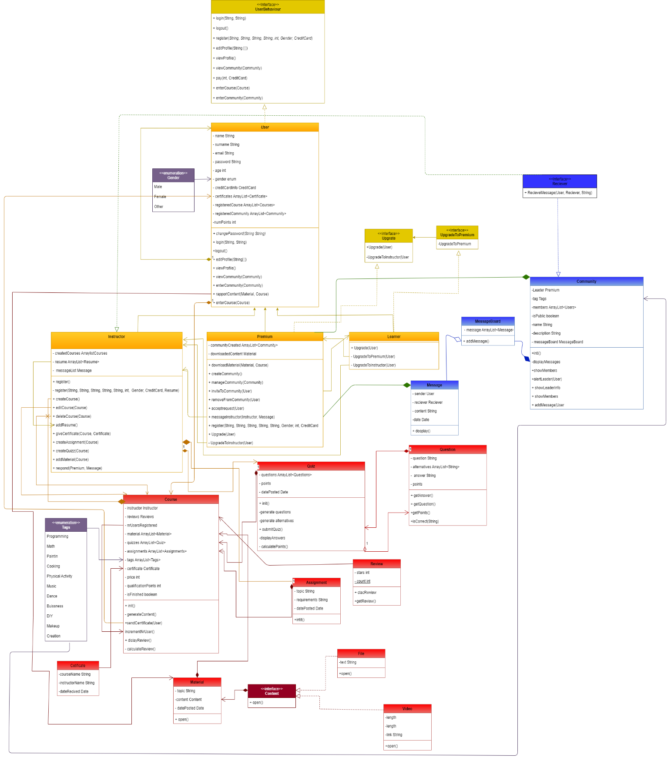

***User Class Diagram***

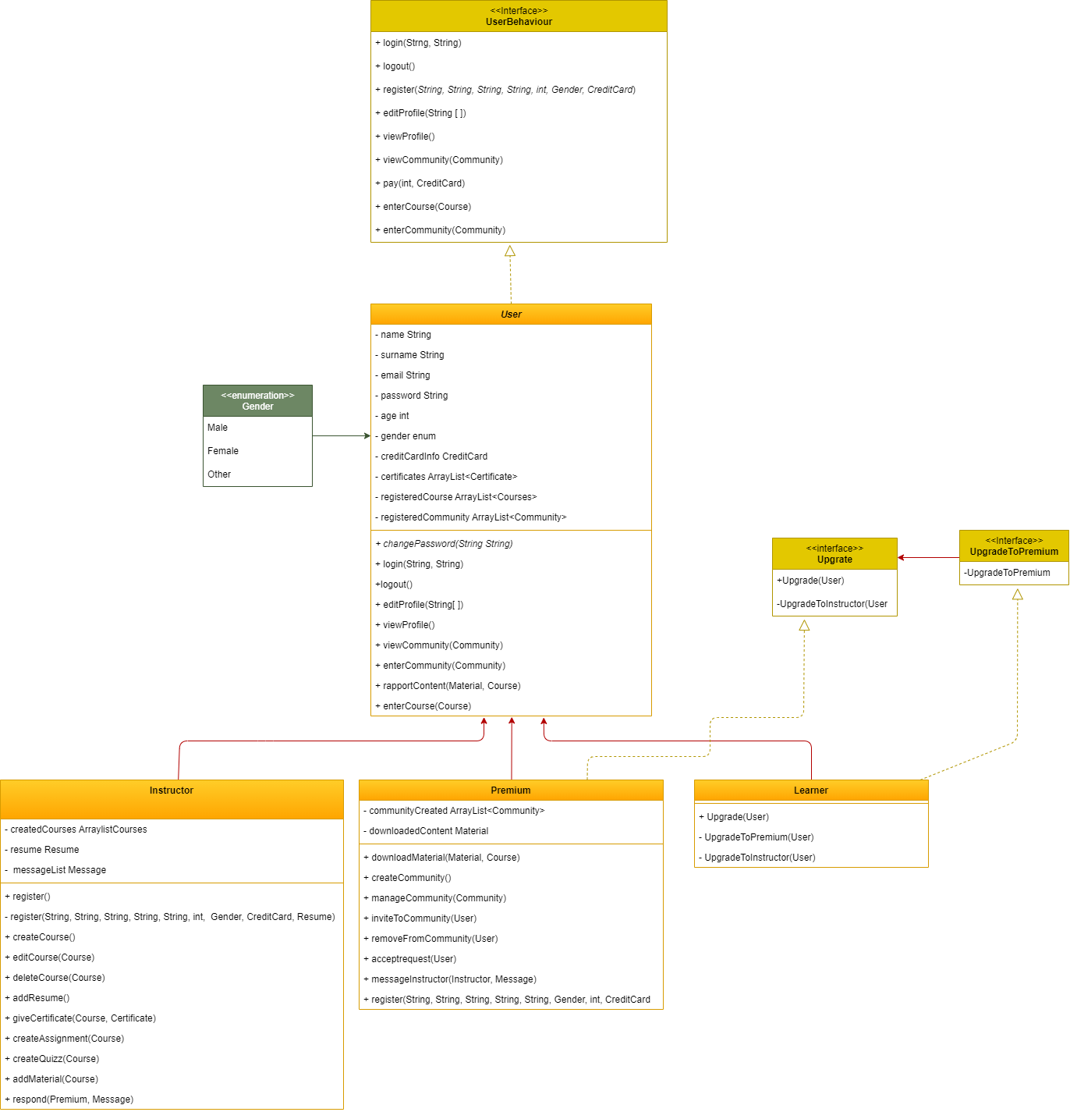

***Course Class Diagram***

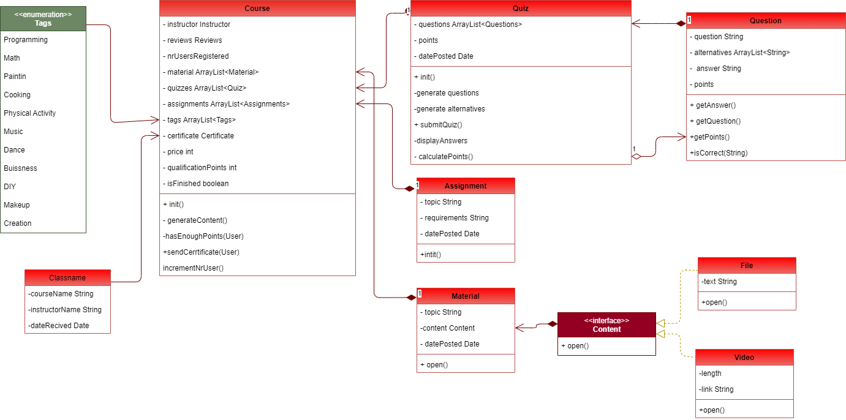

APPENDIX

The appendixes are not always considered part of the actual Requirements Specification and are not always necessary. They may include

* Sample input/output formats, descriptions of cost analysis studies, or results of user surveys;
* Supporting or background information that can help the readers of the Requirements Specification;
* A description of the problems to be solved by the system;
* Special packaging instructions for the code and the media to meet security, export, initial loading, or other requirements.

When appendixes are included, the Requirements Specification should explicitly state whether or not the appendixes are to be considered part of the requirements.

1. **Definitions, Acronyms, and Abbreviations**

Define all terms, acronyms, and abbreviations used in this document.

1. **References**

List all the documents and other materials referenced in this document.

1. **Requirements Traceability Matrix**

The following trace matrix examples show one possible use of naming standards for deliverables (FunctionalArea-DocType-NN). The number has no other meaning than to keep the documents unique. For example, the Bargaining Unit Assignment Process Flow would be BUA-PF-01.

For example (1):

| **Business Requirement** | **Area** | **Deliverables** | **Status** |
| --- | --- | --- | --- |
| BR_LR_01  The system should validate the relationship between Bargaining Unit/Location and Job Class.---Comments: Business Process = "Assigning a Bargaining Unit to an Appointment" (Priority 1) | BUA | BUA-CD-01  Assign BU Conceptual Design | Accepted |
| BUA-PF-01  Derive Bargaining Unit-Process Flow Diagram | Accepted |
| BUA-PF-01  Derive Bargaining Unit-Process Flow Diagram | Accepted |
| BR_LR_09  The system should provide the capability for the Labor Relations Office to maintain the job class/union relationship.---Comments: Business Process = "Maintenance" (Priority 1) | BUA | BUA-CD-01  Assign BU Conceptual Design | Accepted |
| BUA-PF-02  BU Assignment Rules Maint Process Flow Diagram | ReadyForReview |

For example (2):

| **BizReqID** | **Pri** | **Major Area** | **DevTstItems DelivID** | **Deliv Name** | **Status** |
| --- | --- | --- | --- | --- | --- |
| BR_LR_01 | 1 | BUA | BUA-CD-01 | Assign BU Conceptual Design | Accepted |
| BR_LR_01 | 1 | BUA | BUA-DS-02 | Bargaining Unit Assignment DB Modification Description | Accepted |
| BR_LR_01 | 1 | BUA | BUA-PF-01 | Derive Bargaining Unit-Process Flow Diagram | Accepted |
| BR_LR_01 | 1 | BUA | BUA-UCD-01 | BU Assign LR UseCase Diagram | ReadyForReview |
| BR_LR_01 | 1 | BUA | BUA-UCT-001 | BU Assignment by PC UseCase - Add Appointment and Derive UBU | Reviewed |
| BR_LR_01 | 1 | BUA | BUA-UCT-002 | BU Assignment by PC UseCase - Add Appointment (UBU Not Found) | Reviewed |
| BR_LR_01 | 1 | BUA | BUA-UCT-006 | BU Assignment by PC UseCase - Modify Appointment (Removed UBU) | Reviewed |
| BR_LR_09 | 1 | BUA | BUA-CD-01 | Assign BU Conceptual Design | Accepted |
| BR_LR_09 | 1 | BUA | BUA-DS-02 | Bargaining Unit Assignment DB Modification Description | Accepted |
| BR_LR_09 | 1 | BUA | BUA-PF-02 | BU Assignment Rules Maint Process Flow Diagram | Accepted |
| BR_LR_09 | 1 | BUA | BUA-UCD-03 | BU Assign Rules Maint UseCase Diagram | Reviewed |
| BR_LR_09 | 1 | BUA | BUA-UCT-045 | BU Assignment Rules Maint: Successfully Add New Assignment Rule | Reviewed |
| BR_LR_09 | 1 | BUA | BUA-UCT-051 | BU Assignment Rules MaintUseCase: Modify Rule | Reviewed |
| BR_LR_09 | 1 | BUA | BUA-UCT-053 | BU Assignment Rules MaintUseCase - Review Assignment Rules | Reviewed |
| BR_LR_09 | 1 | BUA | BUA-UCT-057 | BU Assignment Rules MaintUseCase: Inactivate Last Rule for a BU | Reviewed |
| BR_LR_09 | 1 | BUA | BUA-UI-02 | BU AssignRules Maint UI Mockups | ReadyForReview |
| BR_LR_09 | 1 | BUA | BUA-TC-021 | BU Assignment Rules Maint TestCase: Add New Rule (Associated Job Class Does Not Exist) - Success | ReadyForReview |
| BR_LR_09 | 1 | BUA | BUA-TC-027 | BU Assignment Rules Maint TestCase: Modify Rule - Success | ReadyForReview |
| BR_LR_09 | 1 | BUA | BUA-TC-035 | BU Assignment Rules Maint TestCase: Add New Rule (Associated Job Class Does Not Exist) - Error Condition | ReadyForReview |
| BR_LR_09 | 1 | BUA | BUA-TC-049 | BU Assignment Rules Maint TestCase: Modify Rule - Error Condition | ReadyForReview |

For example (3):

| **BizReqID** | **CD01** | **CD02** | **CD03** | **CD04** | **UI01** | **UI02** | **UCT01** | **UCT02** | **UCT03** | **TC01** | **TC02** | **TC03** | **TC04** |
| --- | --- | --- | --- | --- | --- | --- | --- | --- | --- | --- | --- | --- | --- |
| BR_LR_01 |  |  | X |  | X |  | X |  |  | X |  | X |  |
| BR_LR_09 | X |  |  | X |  | X |  |  | X |  | X |  | X |
| BR_LR_10 | X |  |  | X |  |  |  |  | X |  | X |  |  |
| BR_LR_11 |  | X |  |  |  |  |  |  |  |  |  |  |  |

1. **Organizing the Requirements**

This section is for information only as an aid in preparing the requirements document.

Detailed requirements tend to be extensive. Give careful consideration to your organization scheme. Some examples of organization schemes are described below:

**By System Mode**

Some systems behave quite differently depending on the mode of operation. For example, a control system may have different sets of functions depending on its mode: training, normal, or emergency.

**By User Class**

Some systems provide different sets of functions to different classes of users. For example, an elevator control system presents different capabilities to passengers, maintenance workers, and fire fighters.

**By Objects**

Objects are real-world entities that have a counterpart within the system. For example, in a patient monitoring system, objects include patients, sensors, nurses, rooms, physicians, medicines, etc. Associated with each object is a set of attributes (of that object) and functions (performed by that object). These functions are also called services, methods, or processes. Note that sets of objects may share attributes and services. These are grouped together as classes.

**By Feature**

A feature is an externally desired service by the system that may require a sequence of inputs to affect the desired result. For example, in a telephone system, features include local call, call forwarding, and conference call. Each feature is generally described in a sequence of stimulus-response pairs, and may include validity checks on inputs, exact sequencing of operations, responses to abnormal situations, including error handling and recovery, effects of parameters, relationships of inputs to outputs, including input/output sequences and formulas for input to output.

**By Stimulus**

Some systems can be best organized by describing their functions in terms of stimuli. For example, the functions of an automatic aircraft landing system may be organized into sections for loss of power, wind shear, sudden change in roll, vertical velocity excessive, etc.

**By Response**

Some systems can be best organized by describing all the functions in support of the generation of a response. For example, the functions of a personnel system may be organized into sections corresponding to all functions associated with generating paychecks, all functions associated with generating a current list of employees, etc.

**By Functional Hierarchy**

When none of the above organizational schemes prove helpful, the overall functionality can be organized into a hierarchy of functions organized by common inputs, common outputs, or common internal data access. Data flow diagrams and data dictionaries can be used to show the relationships between and among the functions and data.

**Additional Comments**

Whenever a new Requirements Specification is contemplated, more than one of the organizational techniques given above may be appropriate. In such cases, organize the specific requirements for multiple hierarchies tailored to the specific needs of the system under specification.

There are many notations, methods, and automated support tools available to aid in the documentation of requirements. For the most part, their usefulness is a function of organization. For example, when organizing by mode, finite state machines or state charts may prove helpful; when organizing by object, object-oriented analysis may prove helpful; when organizing by feature, stimulus-response sequences may prove helpful; and when organizing by functional hierarchy, data flow diagrams and data dictionaries may prove helpful.